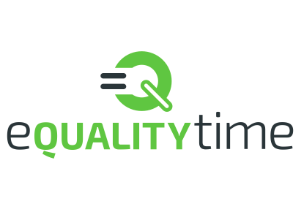



Guide for Teachers

Table of Contents

**Introduction 3**

**Motivation 4**

**Background 5**

**What this course is not 5**

**Lesson Plans 6**

Taking on a single project 7

Change cards 8

Content Warnings 9

Real world examples 10

**Sharing these resources 10**

**Session Guides 11**

Session 1: Introduction 11

Admin Section 11

Inspiration and Fear 13

Security Activity 14

Social Change Activity 17

Session 2: Four steps of change. 20

Introduction 21

Complaining or Changing? 22

Getting information 24

Freedom of Information 25

Setting Goals 29

Sessions 3: Privacy and Threat Modelling. 30

Risk Statements 33

Session 4 Cryptography 34

Session 5: Complete Systems 44

Tiger kidnappings 44

Complex Systems 45

Session 6: Scams and Magic 47

Advance Fee Fraud 50

# Introduction

Welcome to the Tightrope Project, a comprehensive guide for teachers who want to safely guide their students to create social change.

In today's world, it is more important than ever to empower young people to take action and become the change they want to see in the world. However, it is equally important to ensure that they do so in a safe and responsible way. This guide is designed to equip you with the tools and resources you need to create a positive and inclusive classroom environment, foster critical thinking and dialogue, and support your students in developing effective strategies for creating social change. Whether you are a new teacher or a seasoned educator, the Tightrope Project has something for everyone.

# 

*Dutch students protesting about building conditions, 1973, Used under licence from* [*https://www.flickr.com/photos/nationaalarchief/3922564838/*](https://www.flickr.com/photos/nationaalarchief/3922564838/)

# 

# Motivation

Students are increasingly becoming involved in social change as they recognize the importance of making a positive impact on society. This can be seen in a growing interest in social activism, with movements such as the Black Lives Matter protests in the UK and the student-led movement for gun control in the United States. Students are motivated by a desire to create a more just and equitable world and to have their voices heard. They are also concerned about issues such as climate change, inequality, and discrimination, and are eager to make a difference. By being involved in social change, students are able to develop valuable skills, including leadership, teamwork, and problem-solving, and become active and engaged citizens who can make a positive impact on their communities.

It is important for students to understand how to keep themselves safe when taking action for social change for several reasons. Firstly, many students may be targeted by online trolls, hate groups or others who oppose their message and may be at risk of experiencing cyberbullying or harassment. Additionally, there is a risk of students falling victim to online scams or phishing attempts when using social media to promote their cause (Childnet International, 2021). Finally, students may be targeted by law enforcement or other authorities if their activities are deemed to be illegal or disruptive.

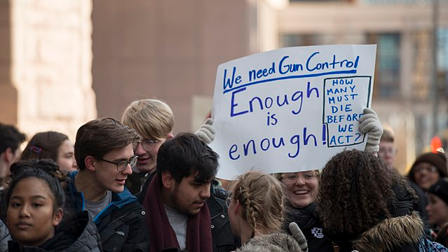

*High school students protesting in favour of gun control, 2018, Used under licence from* [*https://www.flickr.com/photos/fibonacciblue/40409777241*](https://www.flickr.com/photos/fibonacciblue/40409777241/)/

To mitigate these risks, it is crucial that students understand how to keep themselves safe while taking action for social change. This includes understanding the legal implications of their activities and taking steps to ensure that they are not breaking any laws or engaging in activities that could result in harm to themselves or others.

Moreover, teaching students how to take action for social change in a safe and responsible way also helps to develop essential life skills such as critical thinking, problem-solving, and decision-making. It can help students to develop a sense of agency and empowerment, and foster a lifelong commitment to social justice and activism.

# Background

The Tightrope Project is a unique and innovative initiative that has brought together two distinct areas of expertise - cybersecurity and social change. The project was developed by a team of experts in these fields who recognized the need for a comprehensive guide to help teachers empower students to create social change in a safe and responsible way. The collaboration between cybersecurity and social change experts has led to several advantages that make this guide invaluable for teachers.

Firstly, by combining the knowledge and experience of cybersecurity and social change experts, the Tightrope Project has been able to identify the potential risks and challenges that young people may face when attempting to create social change through online platforms. Cybersecurity experts have provided guidance on how to keep students safe while using technology, while social change experts have provided insights into how to promote positive change without inadvertently causing harm.

Secondly, the collaboration between these experts has resulted in a holistic approach to social change that takes into account both the online and offline worlds. The project acknowledges that the use of social media and other online platforms has become a powerful tool for social change, but it also recognizes the importance of taking action in the real world. By combining these two approaches, the Tightrope Project provides teachers with a comprehensive guide that addresses both aspects of social change.

Finally, the collaboration between cybersecurity and social change experts has led to the creation of a guide that is practical and easy to use. The Tightrope Project provides teachers with step-by-step instructions on how to guide students through the process of creating social change, while also providing them with the necessary resources and tools to do so in a safe and responsible way.

# What this course is not

This course covers online safety - it does not cover topics like the following:

* Strong passwords
* VPNs
* Two factor authentication
* Anti-virus software.

Some of those practices are useful in everyday life and it is good to give that information to the students - but our course focuses on the more complex aspects of security, its relationship to power and access, and the trade-offs that people and organisations make every day and attempts to give the students the ability to accurately assess risk for themselves, but also their families and communities.

# Lesson Plans

We provide teachers with six lesson plans that are designed to help students learn how to create social change in a safe and responsible way. The lessons cover a range of topics, from identifying social issues to developing strategies for creating change. Each lesson is structured to be flexible, allowing teachers to tailor the content to their students' needs and interests.

The six lesson plans are as follows:

1. Introduction - a discussion and exercise on the topic of security in the broad sense - including motivations and capabilities of attackers. The second half of the session is on recasting the social change into more immediate and personal goals like “Start a fencing club”, “advocate against animal testing”[1]. The key message of the session is “You secure things by making things hard to use and sometimes that is bad”.
2. Information - this session gives a four step framework for making changes and starts by asking the students to consider the difference between complaining and actually taking action to achieve change. The session focuses on ‘information’ and includes an introduction to Freedom of Information requests.
3. Privacy and Threat Modelling. This session examines a group of different activists and invites the students to understand why some conceal their identity and some don’t. It examines a case study of a very traumatic harassment campaign against an activist for trans-rights and discusses the production of risk assessments.
4. Cryptography. This session introduces Cryptography and discusses how it is used to secure communications in general.
5. Complex Systems. This session leads the students through a set of increasingly complex security systems - starting with the workplace, moving through friendships and relationships and ending with the family[2]. For each example we discuss the challenges inherent to each context and how to manage them.
6. Scams, magic,and future directions. This session has three roles. It’s a general overview of some common scam structures. It’s also a chance to catch up on the progress of any projects started during the course, and finally it’s something of a reveal - showing how the majority of the content of the course is from a Cyber Security background and what students can do to find out more.

## Taking on a single project

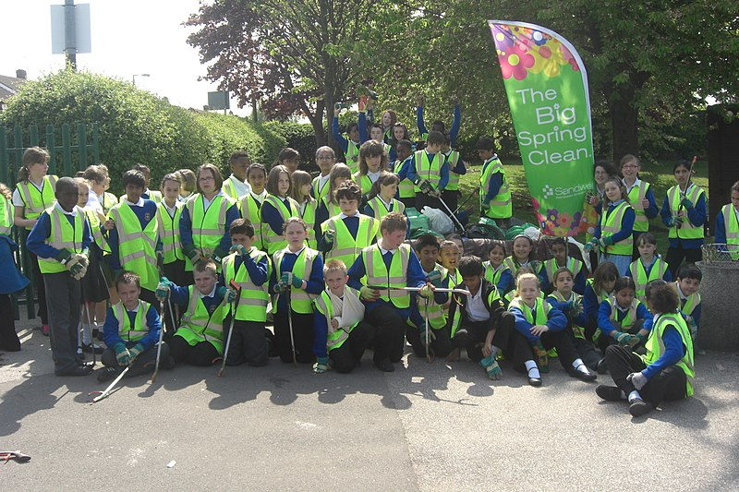

*All Saints Primary school on a litter picking project, 2010, Used under licence from* <https://flickr.com/photos/35317151@N06/4763787826>

While these lesson plans provide a comprehensive framework for teachers to follow, they are also designed to be flexible. If students have a specific social change they are passionate about, teachers can focus on that topic and adapt the lesson plans as needed. This allows students to take ownership of their learning and work collaboratively to create meaningful change.

Examples of small scale social changes that students might be interested in:

1. Reducing food waste: Encouraging classmates and teachers to reduce the amount of food they waste in the school cafeteria, and promoting composting and recycling.
2. Promoting mental health awareness: Organising a school-wide campaign to promote mental health awareness, reduce stigma, and provide support for those struggling with mental health issues.
3. Tackling plastic pollution: Raising awareness of plastic pollution and encouraging classmates and teachers to reduce their use of plastic, by bringing reusable water bottles and lunch boxes to school, for example.
4. Improving accessibility: Identifying areas in the school that may be inaccessible to students with disabilities and working with the school to make necessary improvements.
5. Reducing energy consumption: Encouraging classmates and teachers to turn off lights and electronics when not in use, and promoting the use of energy-efficient appliances in the school.

By focusing on local and achievable goals, students can make a real impact on their school and community while also learning valuable skills for creating positive change.

## Change cards

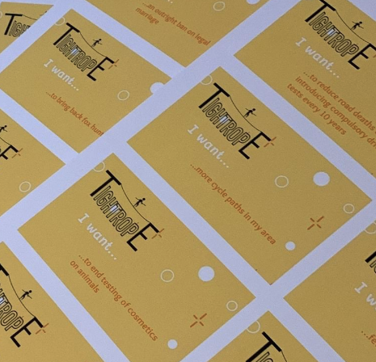

*Our change cards before cutting out, 2023, Released under Creative Commons by us.*

One challenge that teachers may face is that some students may be too afraid or shy to express their ideas about social change. This can make it difficult to engage them in discussions and activities related to creating positive change. To address this issue, the Tightrope Project created 'change cards' that can help students overcome their fears and share their ideas in a safe and non-threatening way. These are available in our resource pack to print out and you should feel free to tailor them to the specific needs and interests of their students. This can be done by brainstorming with students or by using resources such as the United Nations' Sustainable Development Goals[3] to identify key areas of focus.

The change cards are a set of cards that contain a range of social issues, such as climate change, bullying, or poverty. These cards are randomly assigned to students during classroom activities, giving them a specific social issue to focus on during the exercise. By using the change cards, students can express their ideas and opinions about social issues without fear of judgement or criticism from their peers.

The change cards serve several purposes. Firstly, they can help students who are too shy or scared to talk about social issues to overcome their fears and express their ideas in a safe and supportive environment. Secondly, the cards can help students focus their ideas and develop a plan of action for addressing a specific social issue. Finally, the cards can help teachers identify which social issues are important to their students, and tailor their lessons and activities accordingly.

The use of change cards is a creative and innovative approach to helping students engage with social change in a safe and supportive way. By providing students with a specific social issue to focus on, teachers can help them develop the critical thinking and problem-solving skills they need to create positive change in their community.

Cyber Security Background

We used the UK’s Cybersecurity Body of Knowledge (Cybok) framework as the basis for our lesson plans, ensuring that students are taught the skills and knowledge necessary to be responsible and secure digital citizens.

The use of the Cybok syllabus also ensures that the lessons are based on up-to-date, industry-standard cybersecurity practices. This can help students to gain a deeper understanding of cybersecurity issues and give them context for the real-world scenarios they will study in the lessons.

## Content Warnings

The Tightrope Project's lesson plans cover a wide range of topics related to social change, including some that may be sensitive or triggering for some students. These topics may include domestic abuse, doxing, and gender-based violence. To ensure that all students feel safe and supported, the project includes content warnings for these topics, as well as guidance for teachers on how to manage discussions around these issues.

Content warnings are important because they allow students to prepare themselves emotionally and mentally for potentially sensitive material. They give students the opportunity to choose whether they want to engage with a particular topic or not, and allow them to seek out support if needed. Content warnings can also help to create a safe and inclusive learning environment where all students feel valued and supported.

It is important to note that while content warnings and guidance for teachers can be helpful, they are not a substitute for appropriate mental health support. Teachers and schools should also provide students with access to counselling or other support services if needed.

## Real world examples

The Tightrope Project's lesson plans include exercises that give teachers and students the opportunity to make real Freedom of Information (FOI) requests or write directly to elected officials on behalf of the students. These exercises are designed to provide students with practical experience in engaging with government and to promote civic participation and democratic engagement.

The FOI exercises are particularly valuable because they teach students how to access information that is not currently readily available to the public. This can be an empowering experience for students, as they learn how to navigate complex bureaucratic systems and exercise their right to access information.

These exercises can help to foster a lifelong commitment to civic engagement and social change. By learning how to engage with the government and hold elected officials accountable, students can become active and engaged citizens who can make a positive impact on their communities and society as a whole. However, they also are not compulsory - and you should feel free to opt out. In particular - FOI requests can take up to six weeks to give a result, so they only really suit situations where you are delivering one session a week.

# Sharing these resources

The Tightrope Project is committed to promoting a culture of open access and sharing of knowledge. To this end, all the materials developed by the project are licensed under a Creative Commons Attribution-NonCommercial-ShareAlike 4.0 International License. This licence allows anyone to use, share, and adapt the materials for non-commercial purposes, as long as they attribute the work to the Tightrope Project and share any derivative works under the same licence.

The use of an open access licence is essential to the mission of the Tightrope Project. By making our materials freely available, we hope to encourage more teachers to engage their students in discussions and activities related to social change. The open access model also helps to ensure that the materials are accessible to a wider audience, including educators in developing countries and under-resourced communities.

The use of the Creative Commons licence has several benefits. Firstly, it encourages collaboration and knowledge-sharing, as teachers are free to adapt and build upon the existing materials to suit their own needs and contexts. Secondly, it helps to promote transparency and accountability, as anyone can access and scrutinise the materials. Finally, it helps to foster a sense of community and shared ownership, as educators around the world can contribute to the development and improvement of the materials.

# Session Guides

These session guides include example scripts - you are not obliged to follow them but it gives an overview of how other educators have delivered the course.

## Session 1: Introduction

This is the introduction section - a discussion and exercise on the topic of security in the broad sense - including motivations and capabilities of attackers. The second half of the session is on recasting the social change into more immediate and personal goals like “Start a fencing club”, “advocate against animal testing”[4]. The key message of the session is “You secure things by making things hard to use and sometimes that is bad”.

### Admin Section

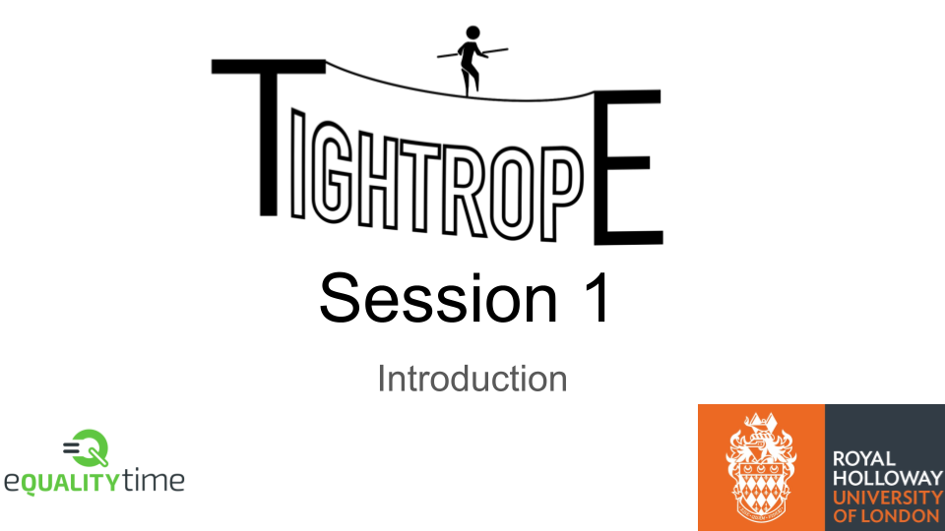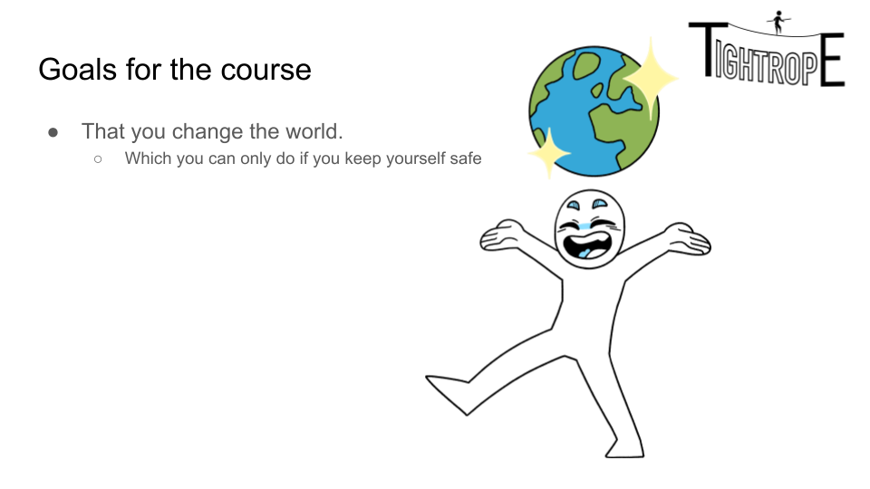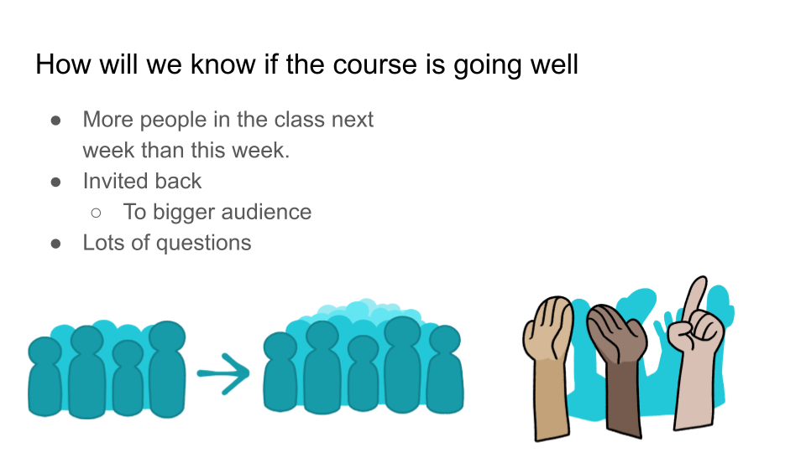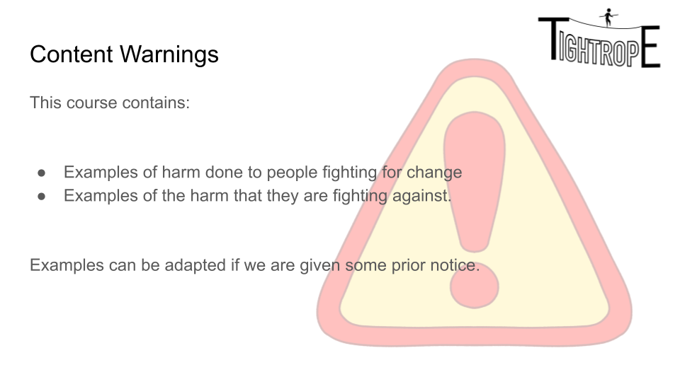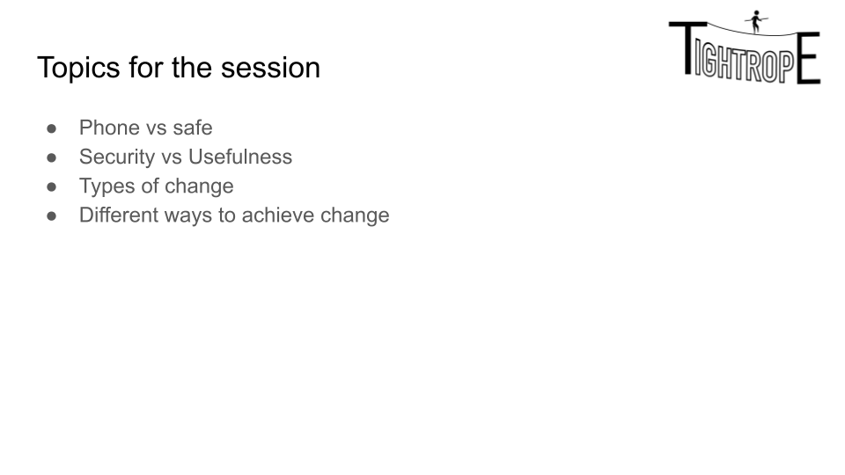

This is the admin section of the course and the session. We cover the goals for the course, encourage people to ask questions, and give a general and specific content warning for the students before introducing the content. A general script for this section might be:

*Hello, I’m X and welcome to our course on cyber security for changemakers. By the end of this course you'll have a better idea of how to talk about security and change than 90% of people who actually have security focused jobs.*

*There are six sessions. Some of them will focus more on security, some more on change. This is the introduction so it has a little bit of everything.*

*We have to start with some admin I'm afraid. Who we are, our goals for the course, a little bit of motivation. That sort of thing. We're then going to look at a very simple security question which will rapidly get more complicated. Then we're going to complain for a while. I hope that sounds good.*

*Our goal for the course is very simple. We want you to change the world. Safely. That means we need to show you how to both manage change and manage risk. And it's very hard to do both of those at the same time. The balance is always hard, that’s way we call the project tightrope.*

*The way I'll know if this course is going well is if there are more people here next week than this week. If I deliver these sessions well enough then you'll start bringing people with you. And it will be obvious to everybody how well it's going. The other good way to find out if it's going well is questions. I'm a firm believer that a lecture with less than 16 questions has failed, but for this course there's a lot of content that is potentially emotionally triggering so that might be a bit of an ambitious goal.*

*The last way I'll know this course is going well is if at the end of the session someone comes up to me and says "The thing I really want to change is this" That could be animal testing, it could be better support for cycling, it could be about awareness of a particular social issue. If you bring something like that to me, I can rewrite the course to support that.*

*The last bit of admin is the content warning. This course contains lots of examples of harm. Examples of harm done to activists and examples of harm done to them. Some of it keeps me up at night. If something you see in this course concerns you the right thing to do it go to a staff member here and say "Look, I've felt horrible since this happened" I can also alter some examples if I've got a bit of notice.*

### Inspiration and Fear

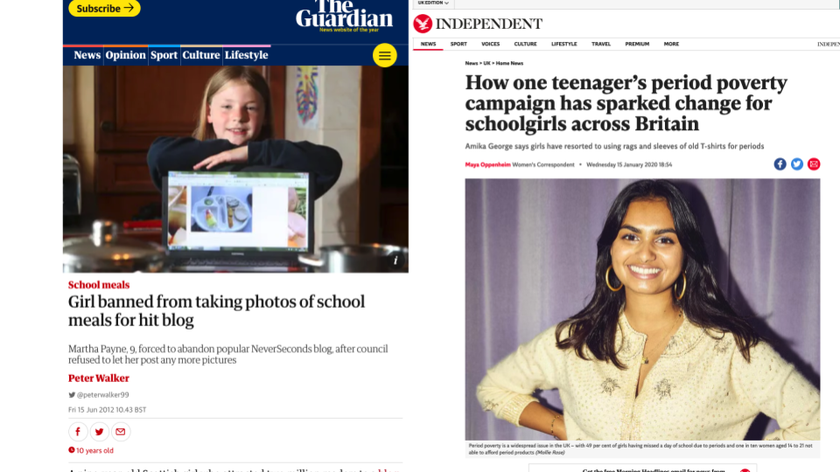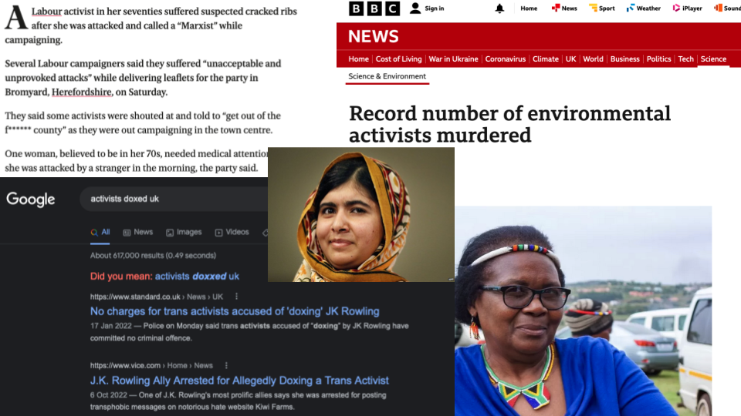

This section is examples of young people who have successfully created change and examples of changemakers who have faced harm. The first slide is an excellent one to localise for your school.

To drive home the ‘risk of harm’ point, we have scrolled through Wikipedia's list of attacks on people using India's freedom of information Law (<https://en.wikipedia.org/wiki/Attacks_on_RTI_activists_in_India>). It is worth mentioning at the time that later in this course we'll use the UK version of that law, and we'll examine the risks around it. It is also worth showing the students Amnesty International's review of the most dangerous types of activism (https://www.amnesty.org.uk/most-dangerous-activism)

### Security Activity

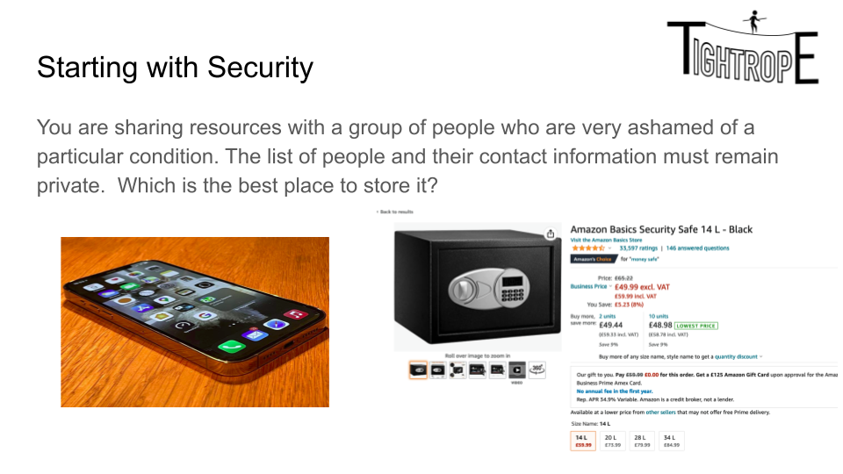

Give the students the prompt above and promote discussion - we have previously had the students vote on which one they thought was secure and then try and persuade the others. This can be pairs, whole class, or small groups. Whenever you get a reasonable point, discuss it and put it on the board. The following slides cover the major points from a security point of view and should be used if the students don’t get them on their own.

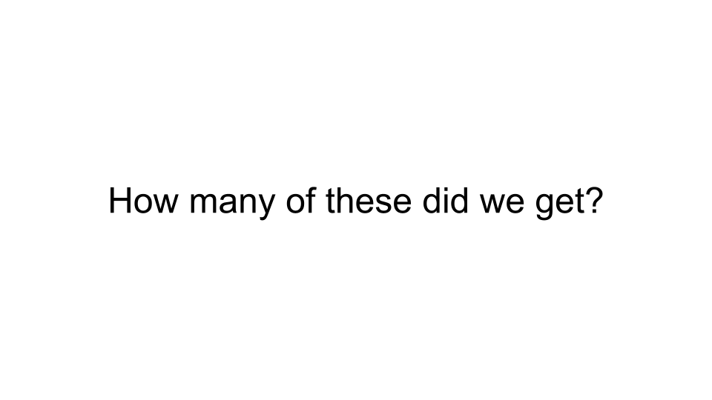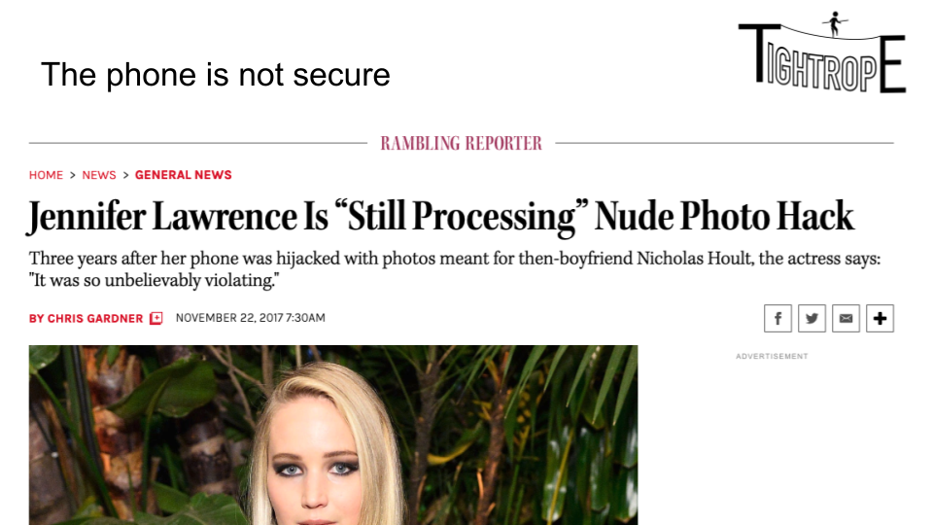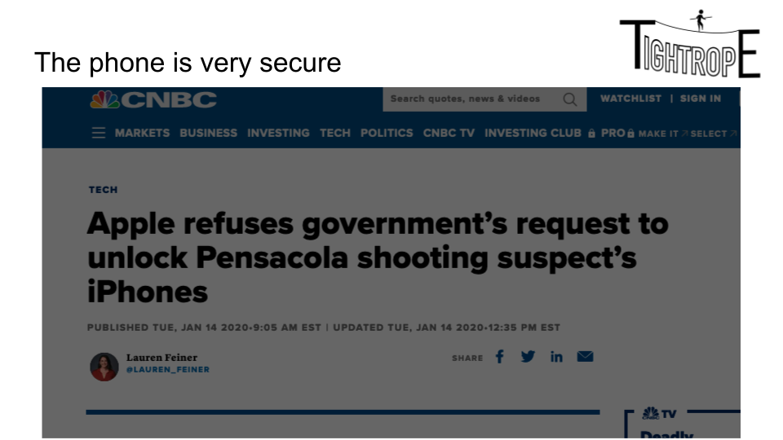

For this set (discussing the circumstances where the phone is the secure and when it isn’t) - it’s worth familiarising yourself with <https://en.wikipedia.org/wiki/2014_celebrity_nude_photo_leak> and <https://www.cnbc.com/2020/01/14/apple-refuses-barr-request-to-unlock-pensacola-shooters-iphones.html>

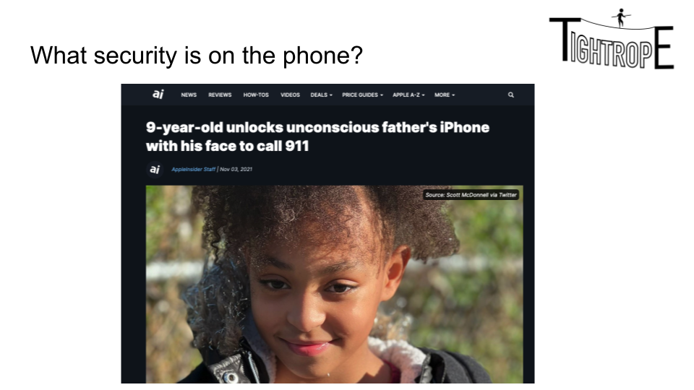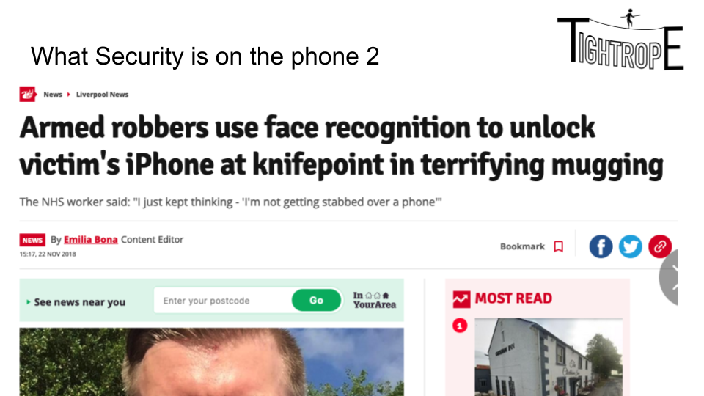

The above two are relatively self explanatory examples of the advantages and disadvantages of a particular type of security. However this is the point to drive home a key message of the course:

*You make things secure by making them harder to use*

Some of the key learning outcomes of this course for the students are recognising that statement and the effects on personal power, access to services, and the marginalisation of communities.

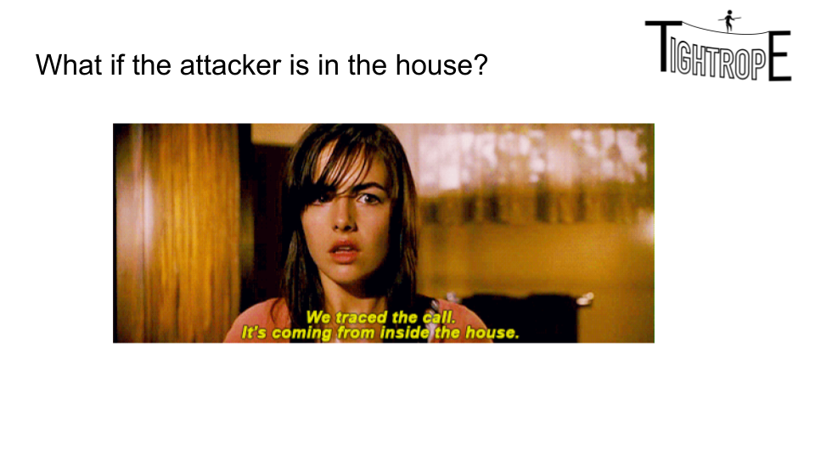

This slide will require some tact, particularly because we’ve only given the students a content warning a few minutes ago. “A new report suggests that over half (61%) of women killed by men in the UK in 2018 were killed by a current or ex partner.” <https://www.bbc.co.uk/news/newsbeat-51572665> and issues like FGM and parental abuse, are serious. We’ll talk about digital intimacy later in the course but this is a good point to start a gentle discussion about abuse within the home. If you would like to avoid the conversation at this stage, then this slide is about how your phone is generally always with you, but a landlord or roommate might have access to it.

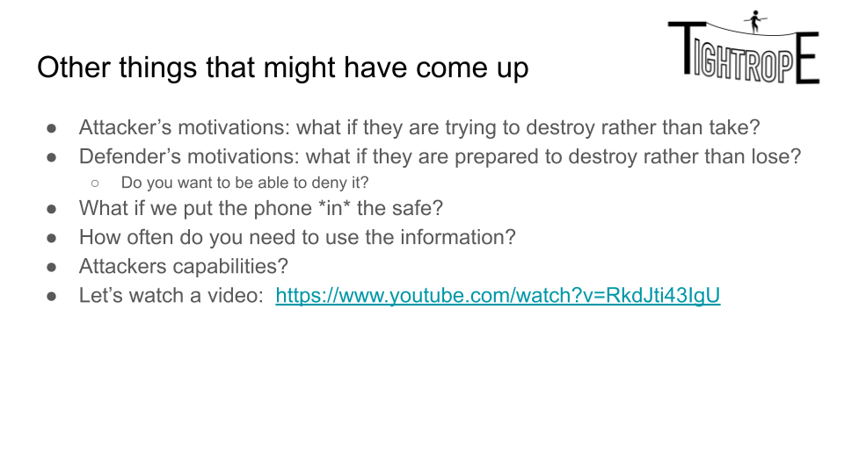

This is a short set of reminders for you about things that are worth discussing if you haven’t already. The video is important - that model of safe wasn’t chosen by accident. It’s Amazon’s recommended product at the time of writing and it’s quite insecure. The video is a locksmith opening it extremely quickly. It’s normally quite an effective way of getting some of Team Safe to change their minds.

The attacker’s motivations part is something students normally miss. Ask people to put up their hands if they use a bike lock. Then ask them if that stops their tyres being slashed.

For your interest, there is some light stand-up comedy on the topic here: <https://www.youtube.com/watch?v=SdoWHtNOd38>

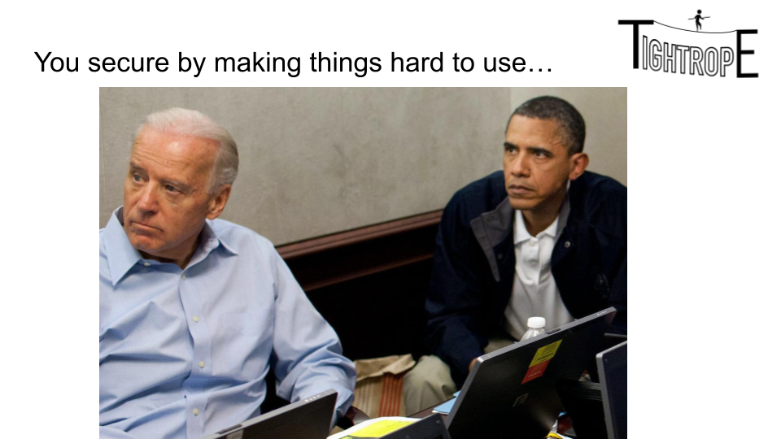

This is the slide that makes explicit what we mentioned earlier. A sample script might be:

*Maybe the best thing to do is to put the information on the phone, but the phone in the safe, weld the safe shut, put it in a pit and pour concrete over it, then install security cameras. That would be pretty secure right? Sure, but it’s also hard to use. Like, if it’s information you don’t actually need, you should just destroy it.*

*This is a photo of two guys watching live updates on the killing of OBL - between them is a burn bag. A bag designed specifically so that you can quickly and effectively burn the documents inside it. Best way to keep something secret is to destroy it. The Film Argo, if anyone has seen it, spends quite a bit of time in the opening demonstrating how important this can be.*

*Best way to keep a secret is not to know it or have access to it. This is very true in business and in life. In fact it’s one of the key parts of GDPR - you shouldn’t collect data you aren’t meant to have.*

*Literally nothing worth knowing starts with “I shouldn’t tell you this”. And if you remember nothing else from this talk remember this: the more secrets you have in your head, the harder your life is.*

*Now, I didn’t give you the option to say “Actually I wouldn’t do either” so it’s a bit unfair, Sorry.*

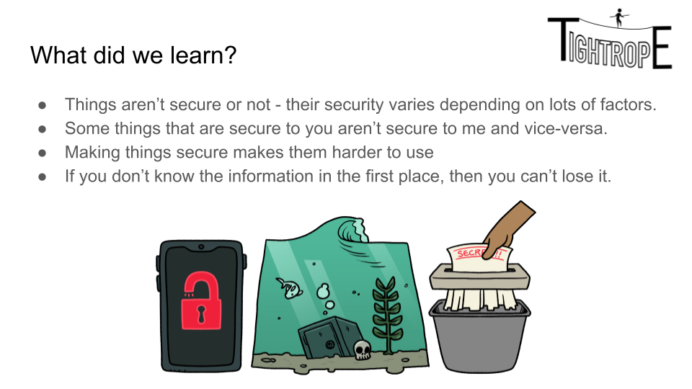

This is a summary slide for the exercise.

### Social Change Activity

The purpose of this activity is to get students to think about things they can change or influence locally. Some students may have arrived with a set of things they are already passionate about: that’s great.

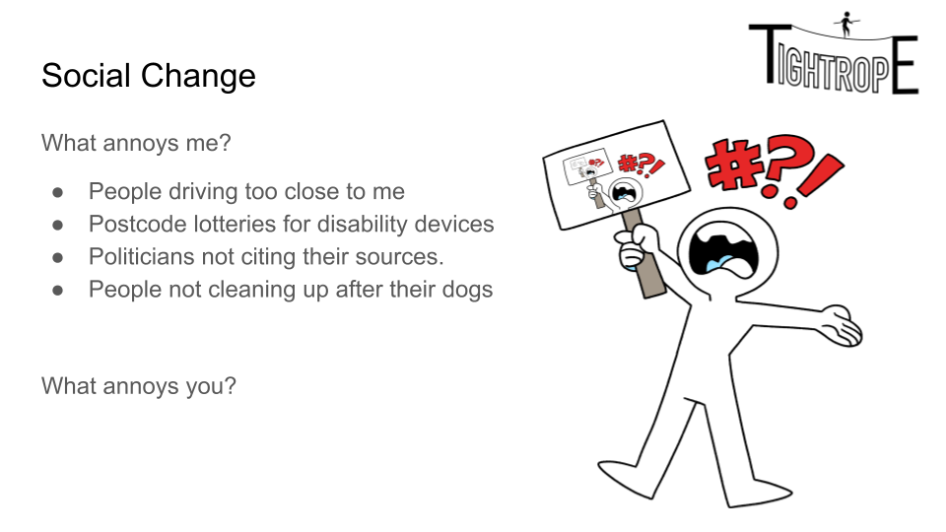

The first activity is to get the students to list things that annoy them. There will be some joke answers “My little brother”, “Transfer Windows”, but take them seriously and write them down - it will be useful for later. If the class isn’t warmed up, this might take a while. That’s okay. In general you want some big things “Climate Change” and some small things “There should be a local woman’s running club” - it’s excellent if you get some that make good projects: “The school should have better lighting on the access path”

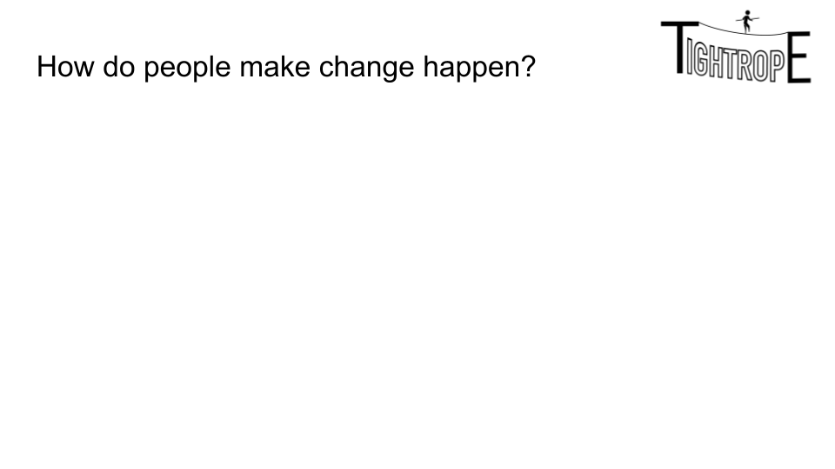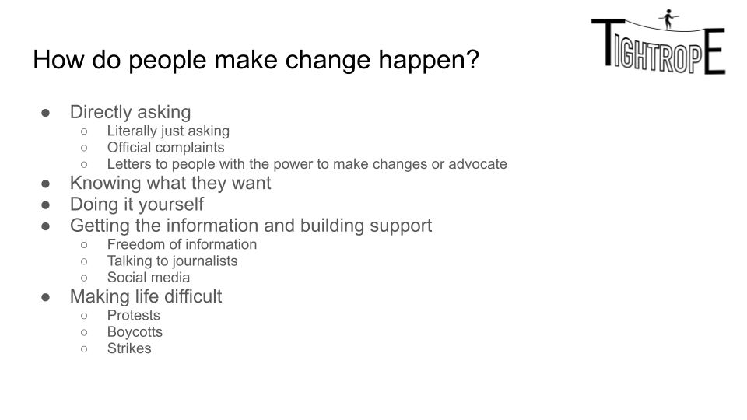

This is another listing exercise. The purpose is:

* To get the students to think about the different ways that change can happen.
* For one of the students to recommend violent protest, which is your cue to set the ground rule of “no illegal stuff”

You can discuss this in more detail:

From: <https://www.journalofdemocracy.org/articles/the-future-of-nonviolent-resistance-2/>

*“Among the 565 campaigns that have both begun and ended over the past 120 years, about 51 percent of the nonviolent campaigns have succeeded outright, while only about* ***26 percent*** *of the violent ones have. Nonviolent resistance thus outperforms violence by a 2-to-1 margin.”*

But we can be clear that in the UK there is zero history of violence being successful.

Once they have finished listing examples, move on to the second slide to talk about anything they might have missed.

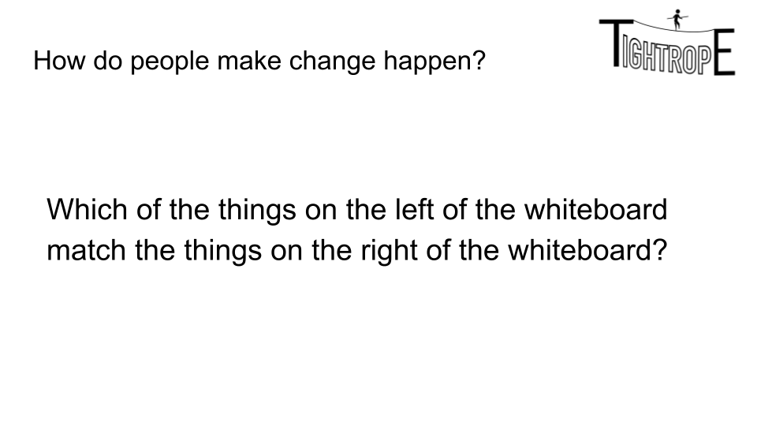

This is the last part of this set and you can use it to uncover causes they have missed (“What things would you use a boycott for?”) or methods they might have missed “So how are you going to get your parents to support your vegetarian diet?” If you have time, then it’s great to get into a conversation about *exactly* why it’s it would be ridiculous to use a petition (or any method) with one cause but not another. If they struggle to give examples of causes (they might be feeling vulnerable about things that are important to them) you can give out the cause cards as a prompt.

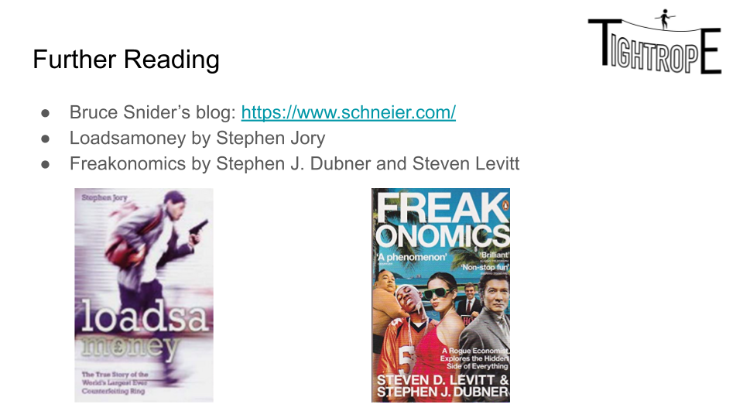

The blog is an excellent source of security news and commentary, and the books are the right level for bright high-schoolers. Loadsmoney is the autobiography of a ‘successful’ criminal and ends up covering a lot of security basics. Freakonomics also has a lot of focus on crime, but it’s value is mostly in terms of incentives.

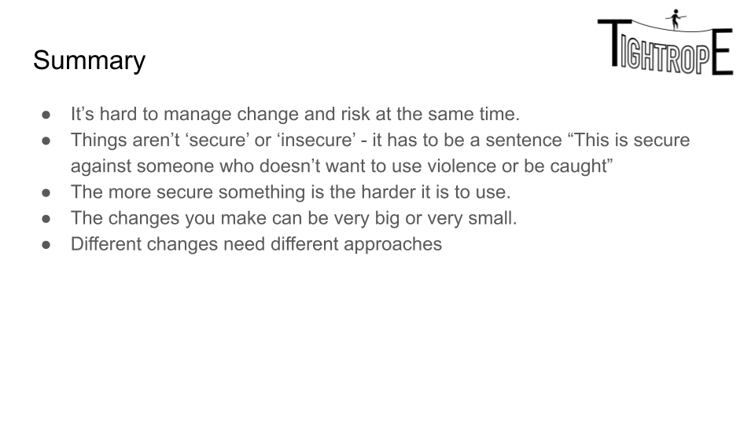

## Session 2: Four steps of change.

This session gives a four step framework for making changes and starts by asking the students to consider the difference between complaining and actually taking action to achieve change. The session focuses on ‘information’ and includes an introduction to Freedom of Information requests.

During this lesson you can make a Freedom of Information request with the class. This will require a little prep.

1. Register an account with <https://www.theyworkforyou.com/>
2. If you have something that is a personal interest, then you can find the relevant local authority and ask your question.
3. If the students have shown a clear passion for something local, then you can help them craft the request.
4. If you don’t want to share your own interests with the students, you can make a Freedom of Information Request directly to your own school.
   1. Talk to your admin staff first and agree something reasonable that might be worth requesting. This is an example of a request that isn’t much load on the admin team: <https://www.whatdotheyknow.com/request/school_timetable_109#incoming-2159448> and this is one that is a little more interesting but still easy. <https://www.whatdotheyknow.com/request/free_school_meals_data_31#incoming-1596107>

The advantage of doing an FOI to your own admin staff is that you can be reasonably sure they will reply nicely and will do so before the end of the course. On the other hand, this also means that your students might get a false impression of how easy it is.

Definitely make sure that you are making the request as a teacher. Don’t let the students sign it.

### Introduction

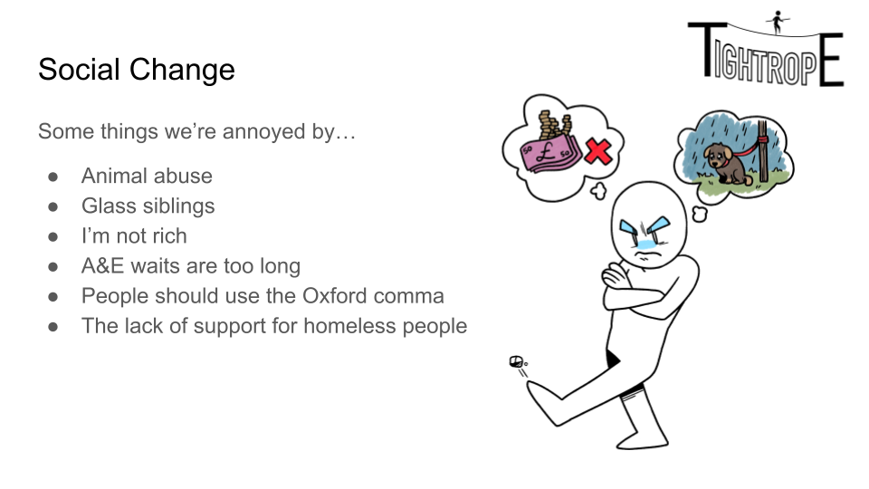

Edit this slide (if you like) to remind the students of the things that they were passionate about in the last session.

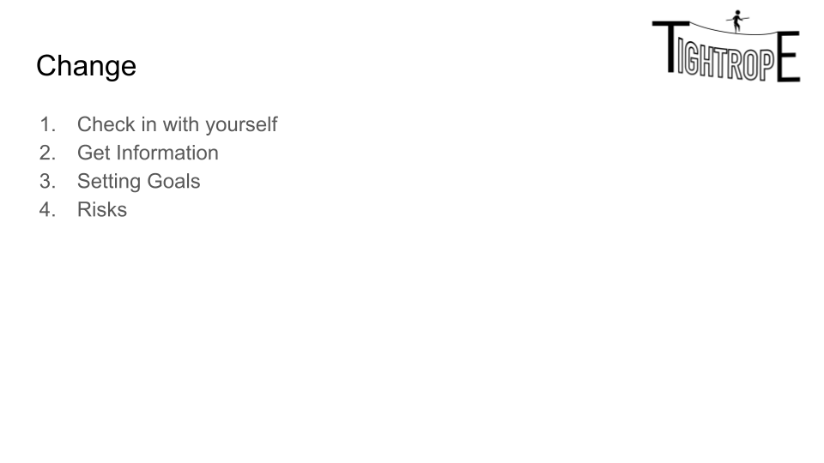

We’re giving the students a four step plan to make change. You can be honest with the student that this isn’t based on any particular study - it’s just a way of separating out the things they need to know: in practice they’ll loop repeatedly through the list and often do several stages at once.

### Complaining or Changing?

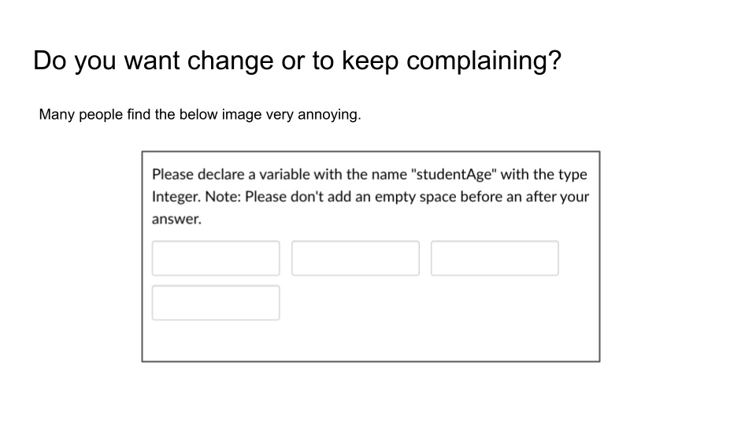

You can tell the students that the reason the image is upsetting is because the amount of typing the website design could have done to remove the annoying spaces (“.trim()”) is less typing than the message to the users.

We’re using this as an example of something that is annoying, but not particularly important.[5]

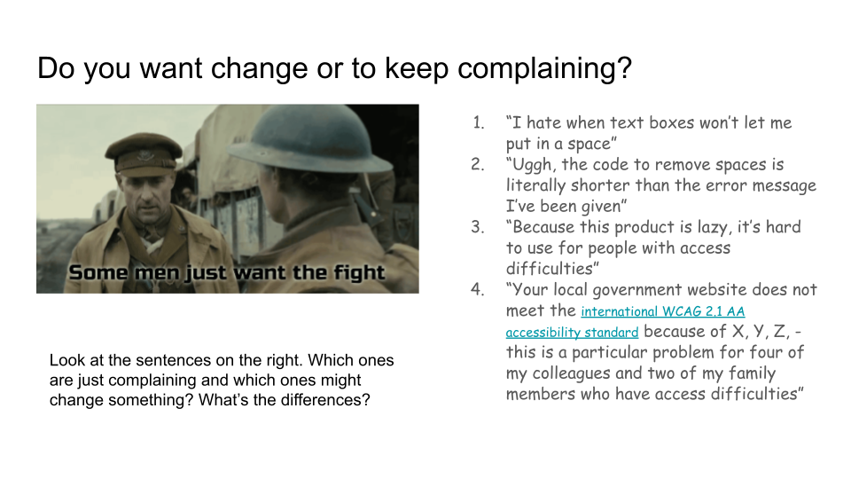

The slide is relatively clear - point out to the students that the examples get progressively more informative and make it easy for the recipient to change things. “Information is everything”.

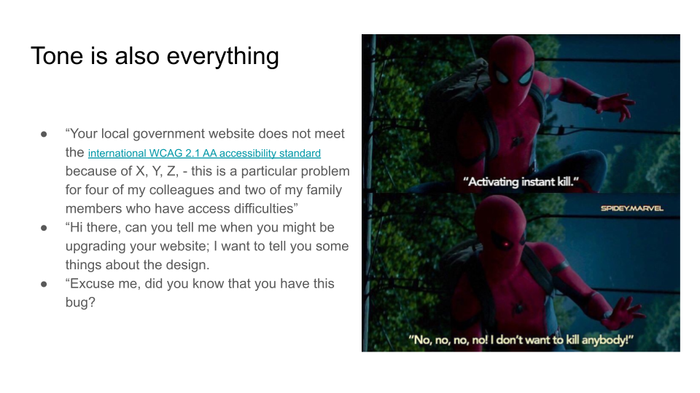

This is the other side of “Are you complaining or are you changing”. The key message for the students is “Start politely and helpfully”.

This is an excellent point for a personal anecdote - if you can give the students examples of something you just enjoy complaining about and something you actually want to change then it’s easy to see the difference.

### Getting information

There are two ways to run this next session. It works through a set of example ‘problems’ to find out how big or serious they are’. The first is to follow the example slides that contain problems students gave us in the testing. The second is to take the list of problems the students gave you in the last session and do no more than five minutes Googling on each to see what you can find. The point you are making is that you can make a surprising amount of progress in five minutes.

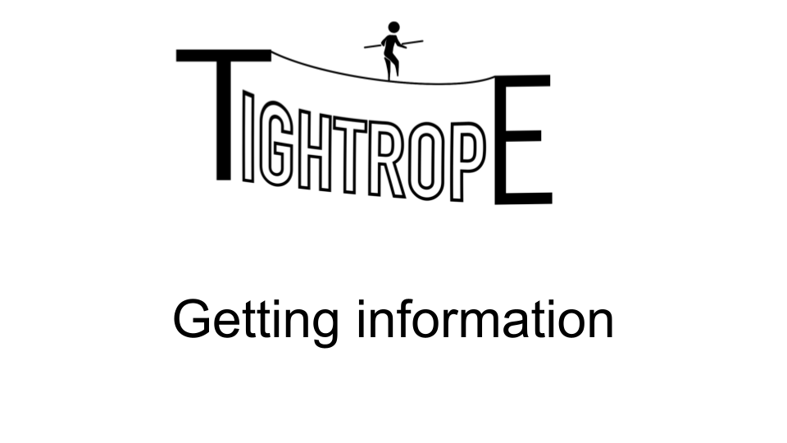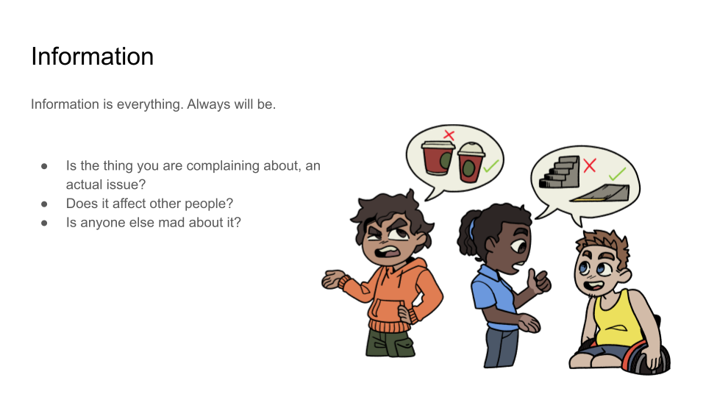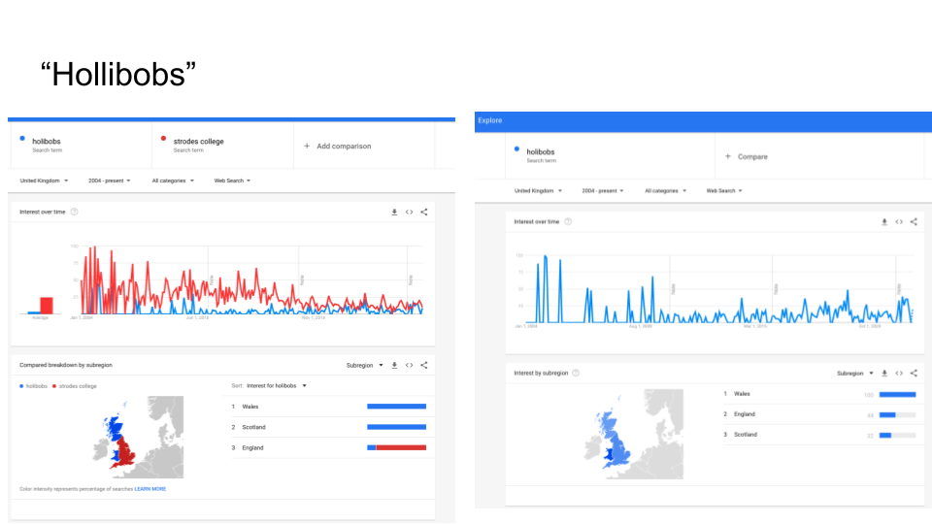In a previous session, a student complained about the use of the word ‘Hollibobs’ to mean holidays. Here we’ve used Google Trends to point out it’s not that common a thing and they can probably relax about it.[6]

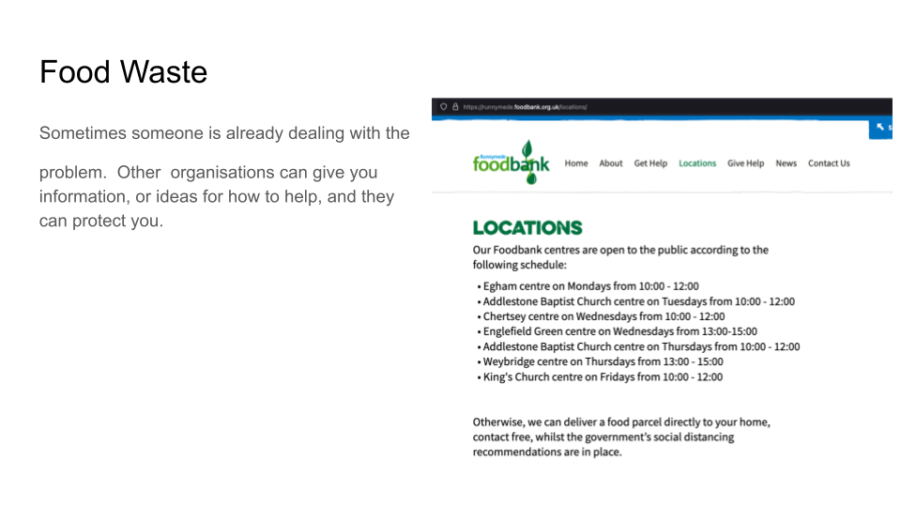

A student passionate about food waste was surprised to find that there was a food bank to volunteer at just down the street. It lead to a discussion about a project were the college itself formed links with the food bank.

### Freedom of Information

This is a fun session with a bit of a twist. We’re going to introduce a problem, then we are going to move away from it to talk about Freedom of Information, and then we are going to come back to see that Freedom of Information might help.

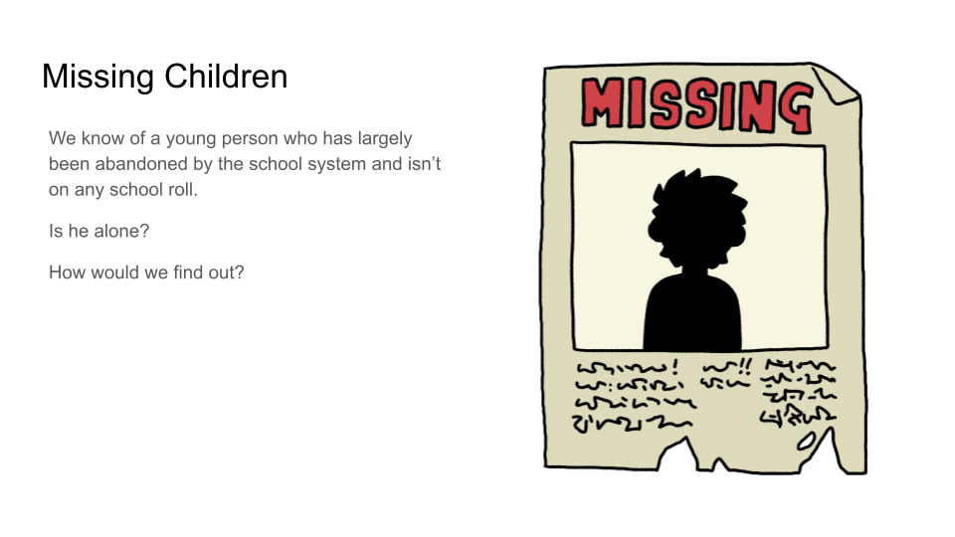

Present this slide to the students and ask how they would find out information about this. Maybe it’s a big problem, maybe it isn’t. How do we find out? Take as much time as you like.

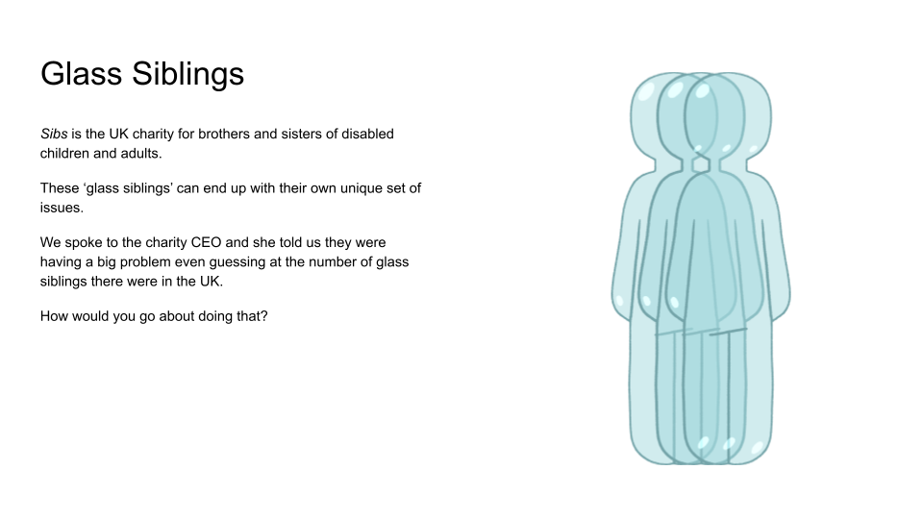

Now we move onto a different problem. The issue of Glass Siblings. Again ask the students for ideas. Surveys are the obvious answer - point out to the students how inaccurate and expensive they can be (particular nationally) but concede that might be the best approach (it was the one the CEO was planning on).

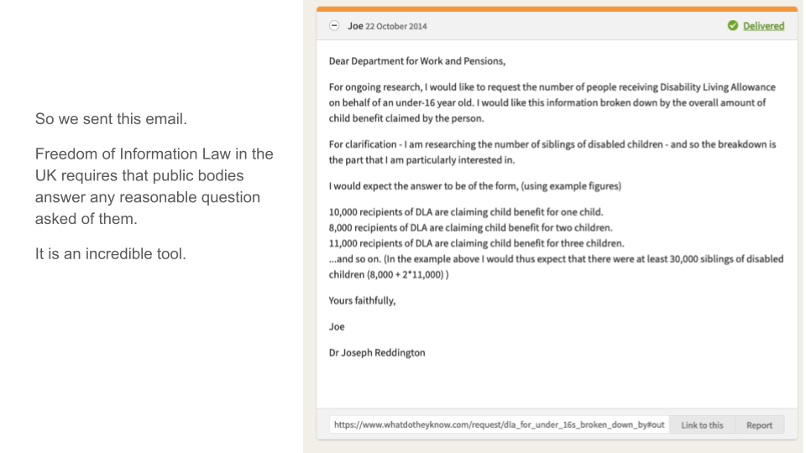

You should read through the first few pages of <https://www.whatdotheyknow.com/help/about> - the questions will come up.

Talk them through the maths of this. This is a fairly complex FOI request and it only worked because it was clear that

* It was for a good cause - the majority of FOI requests are from journalists who want to write about something embarrassing, or sales staff trying to generate leads. It was something that a data scientist in DWP would find interesting.
* It was clearly written and patiently followed up. Lots of FOIs are straight up abusive.

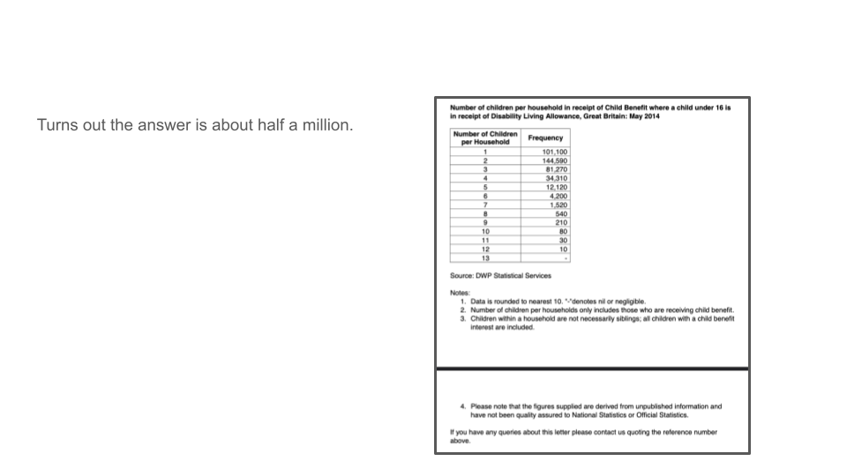

Happily the request was successful, the charity went on to use it a lot and it was much cheaper and more accurate than a survey.

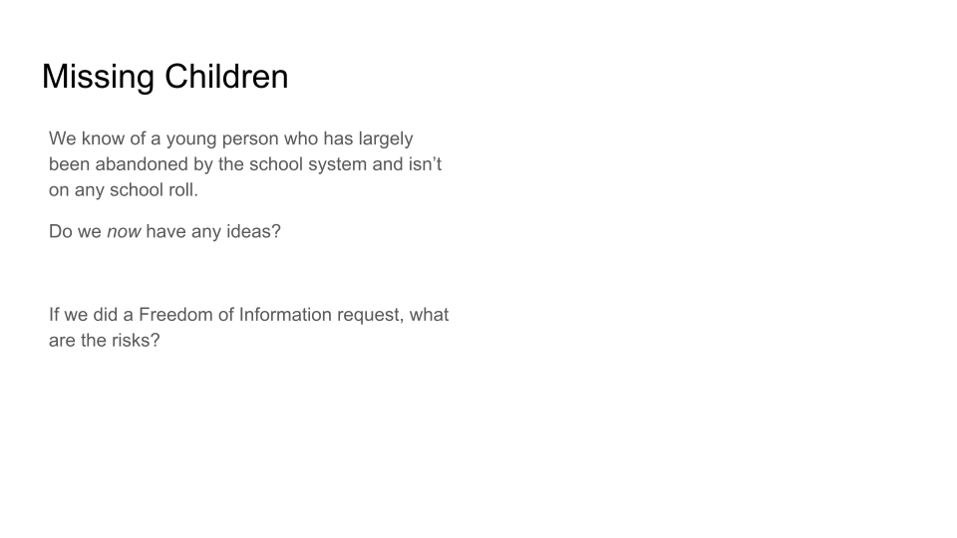

Back to this problem - the students should now be reasonably likely to suggest an FOI request. But they should work out who (the local educational authority needs to record the removal from rolls so that’s who), and how to write it out. The whole theme here is that the more information you get the easier it is to get even more information.

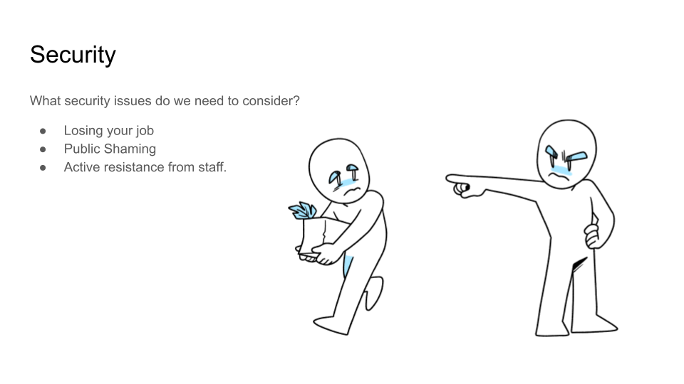

Ask the students what can go wrong for them personally if they make a freedom of information request. You want them to come up with specific problems that might happen. Once they are done, tell them that the person who did the Glass Sibling FOI request, and who also went on to use FOI to identify a postcode lottery in a particular type of NHS provision, ended up leaving his job at a university over it and changing careers completely.[7] It’s possible (and, indeed, likely), that you’ll annoy people by asking questions that they don’t want public.

Now there are three paths from here:

* You can show the students a FOI request made (as part of this course) about the missing children here: <https://www.whatdotheyknow.com/request/children_removed_from_school_rol#incoming-2213595>. Point out the background section and how polite but specific the request is. Look at the replies that came in and the eventual pdf file - you can see that it’s a surprisingly large number and *nobody seems to know why*.
* You make your own missing children FOI request, using ours as a template, to your local authority. Please email us before you do this, because it’s quite possible someone already made the request in your area and it’s not nice to keep making the same requests over and over again.
* You make a request of your own, live, in front of the students.

### Setting Goals

This is a fairly simple section - get the students to set some goals for changes they want (this is a good point to use the Change Cards). They’ll discover they need more information and they’ll go around the ‘set goals, get information, change goals’ loop a couple of times.

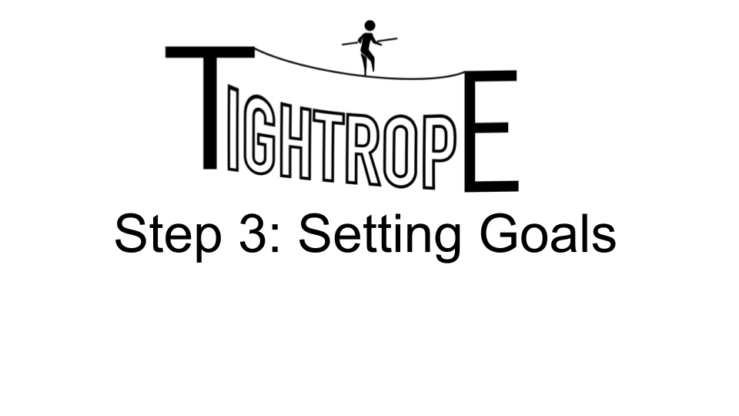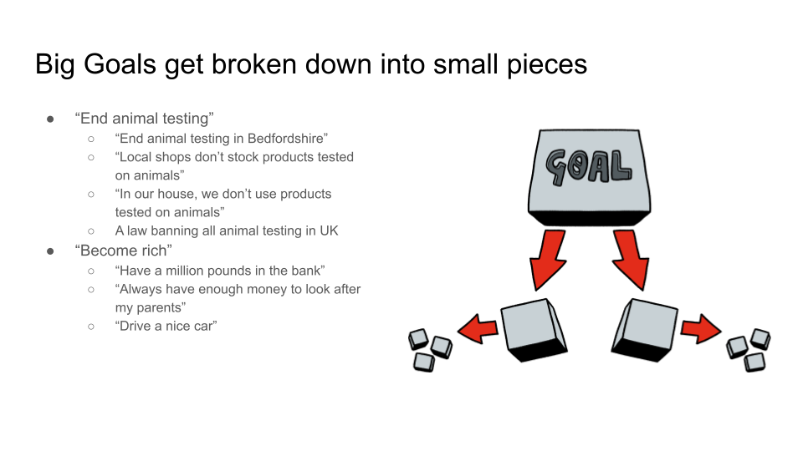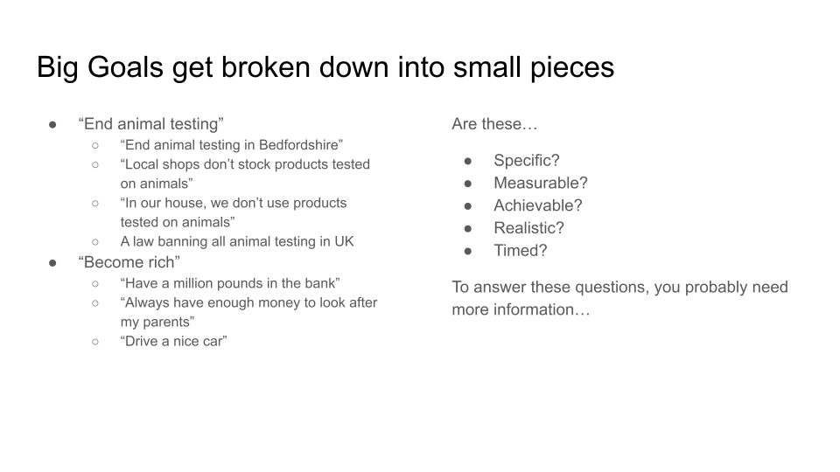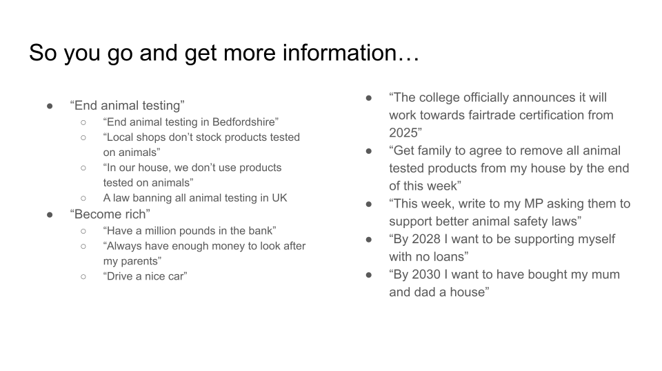

## Sessions 3: Privacy and Threat Modelling.

This session examines a group of different activists and invites the students to understand why some conceal their identity and some don’t. It examines a case study of a very traumatic harassment campaign against an activist for trans-rights and discusses the production of risk assessments.

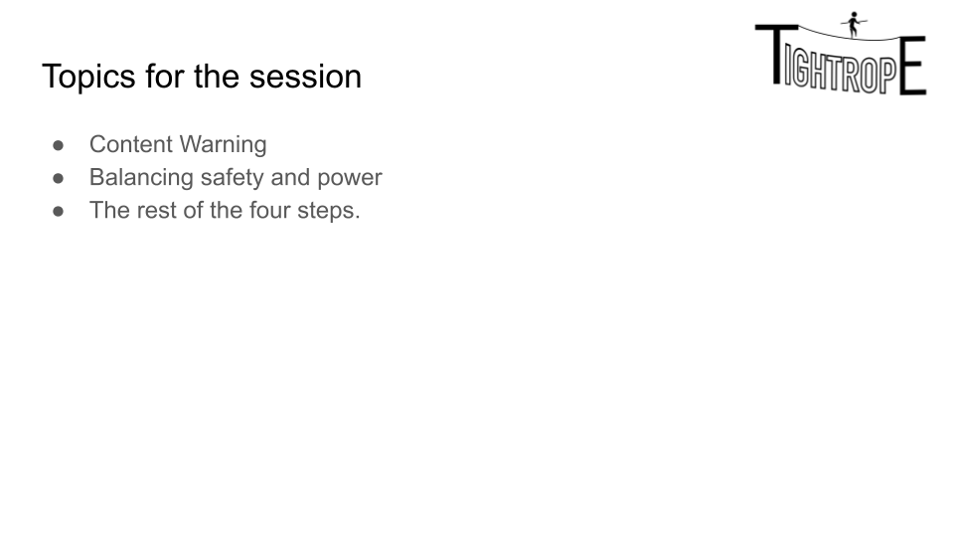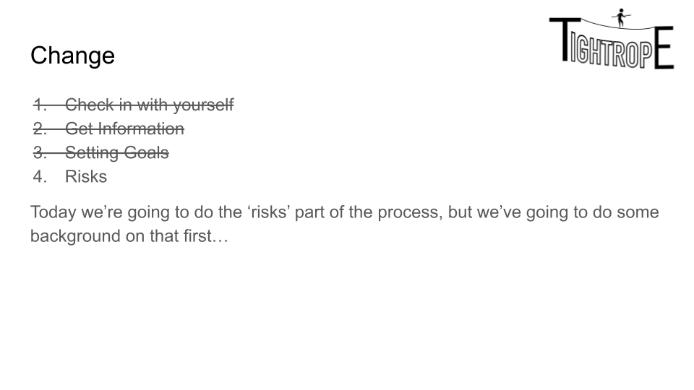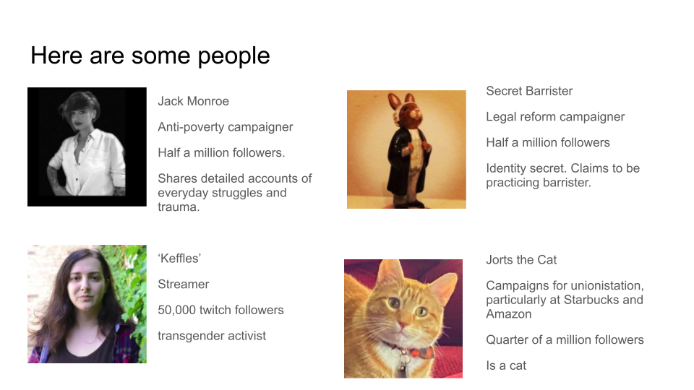

Have a look at these people’s social media before the session. Work through them and then ask the class why some of them are very private and why some of them share all of their daily struggles and trama.

The conclusion that you want them to reach is “There is a balance of power and privacy. When you give up privacy to gain power, you can do more but you expose yourself to more risk”. It’s an extension to the idea of “When you secure things you make them harder to use”

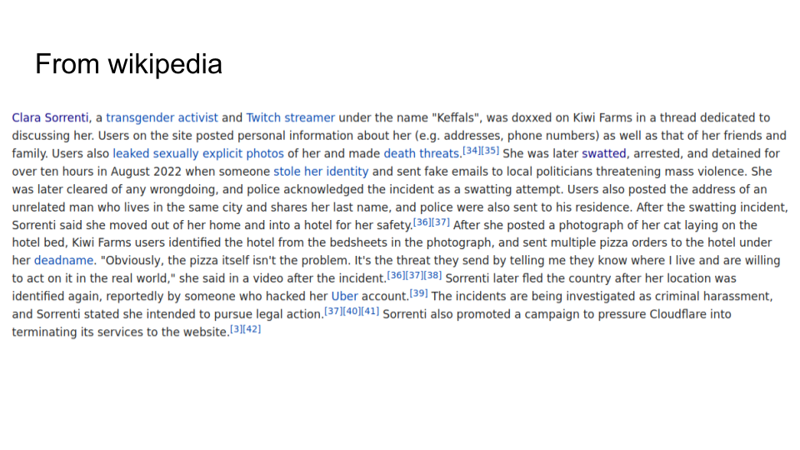

We have them read this in silence. Familiarise yourself with Sorrenti’s wikipedia article in advance and also the one for Kwiw Farms in case you get any questions on it.

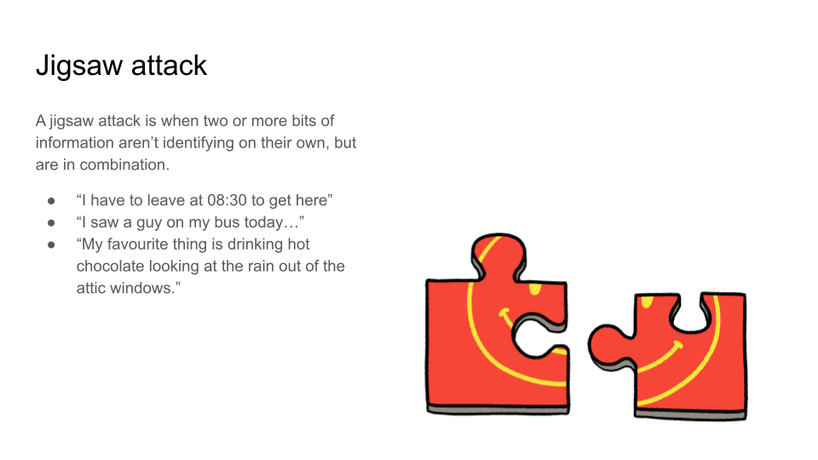

Talk a little bit about the information they reveal every day that tells us more about them, and which can contribute to a Jigsaw attack like that suffered by the streamer.

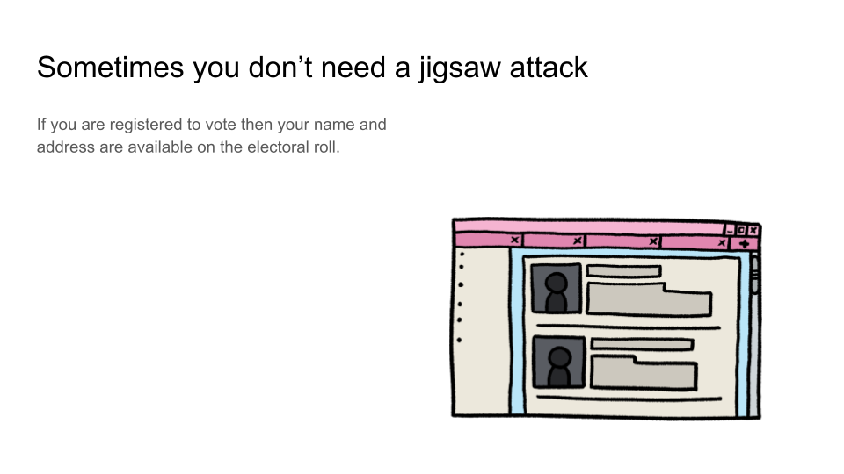This is a good time to point out to them that their (or more likely, their parent’s) names and addresses are likely on the electoral roll - and you can wander in look people up.[8]

The point we are making here is that sometimes we can focus on the wrong part of security: people can worry about how strong their door lock is, when a thief might otherwise just break a window. This is preparation for the introduction of risk statements next.

### Risk Statements

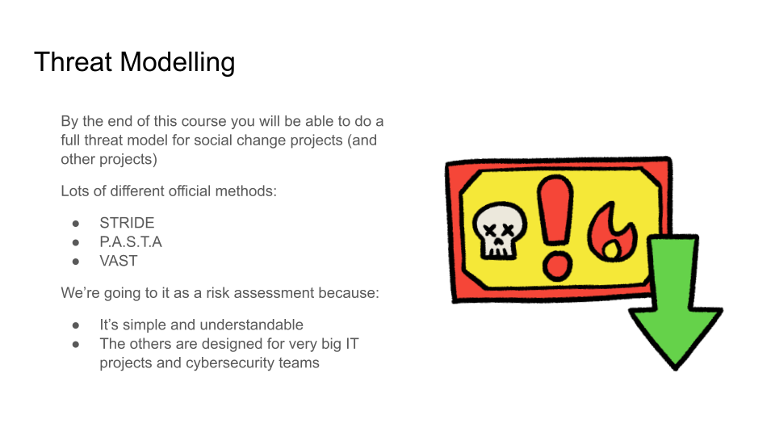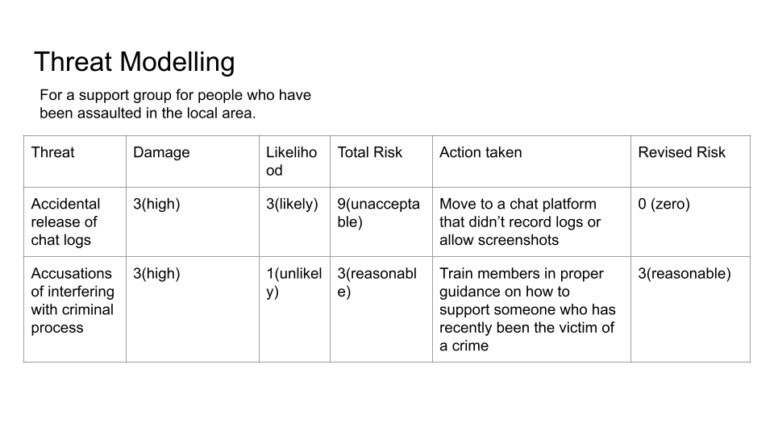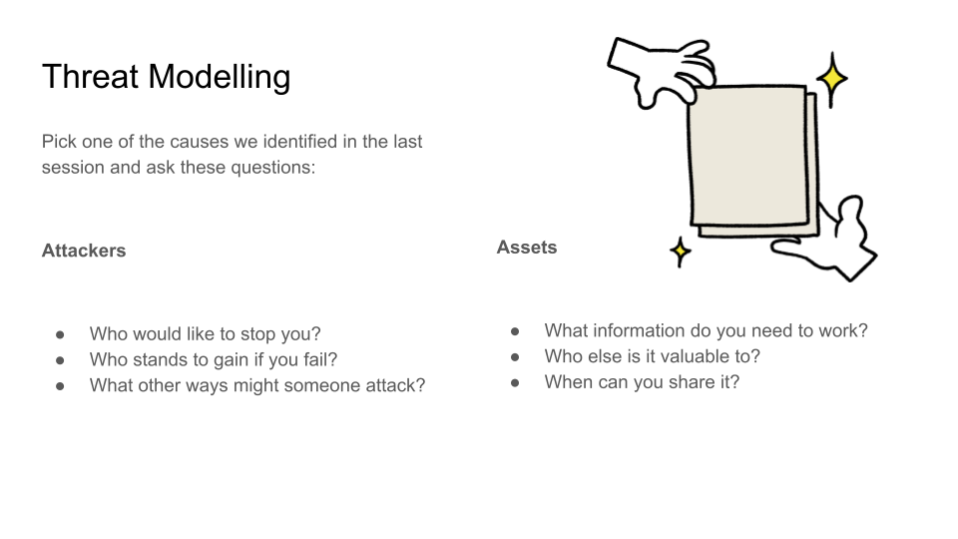

This exercise is risk statement writing. Give them each a Change Card and get them to write out 20 risks.[9] Get them to be specific. Then they estimate how likely each of them are on a scale of 1-5, then how bad each one would be on a scale of 1-5 and so on in classic risk assessment style

Take them through the process in your remaining time. One game is that works well is putting them in pairs and getting them to come up with a risk that isn’t on the other person’s list. They get a point each time they do so.

The things that you want them to take from this are:

* There are lots of risks
* The first few they thought of were not the ones with the biggest impact.
* It works a lot better to write down specific worries and the mitigating actions than it does to just worry.[10]

## Session 4 Cryptography

This session aims at introducing the notion of cryptography and what cryptography can provide in terms of security. There will be a bit of history as well, which is intended to show how our understanding of security has evolved. Some parts of the session are a bit technical, but hopefully this guide will support in running through these.

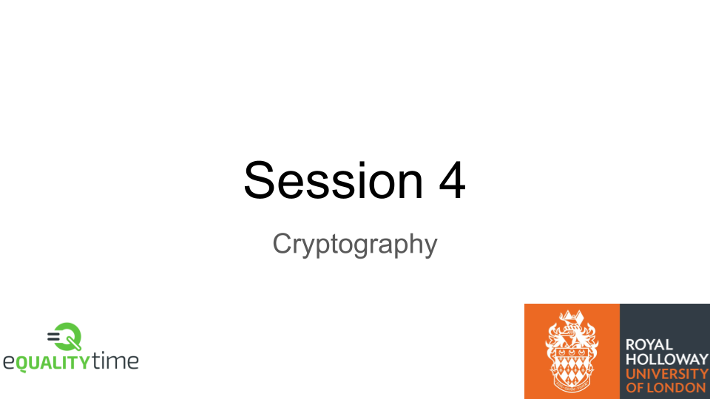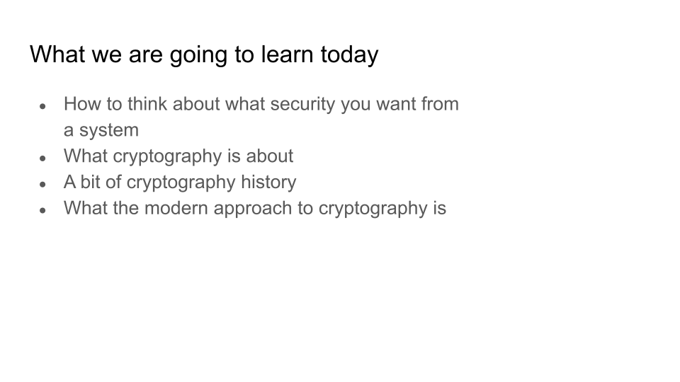

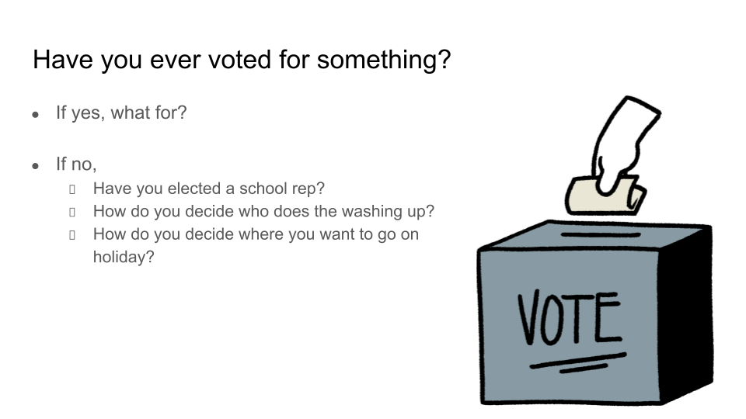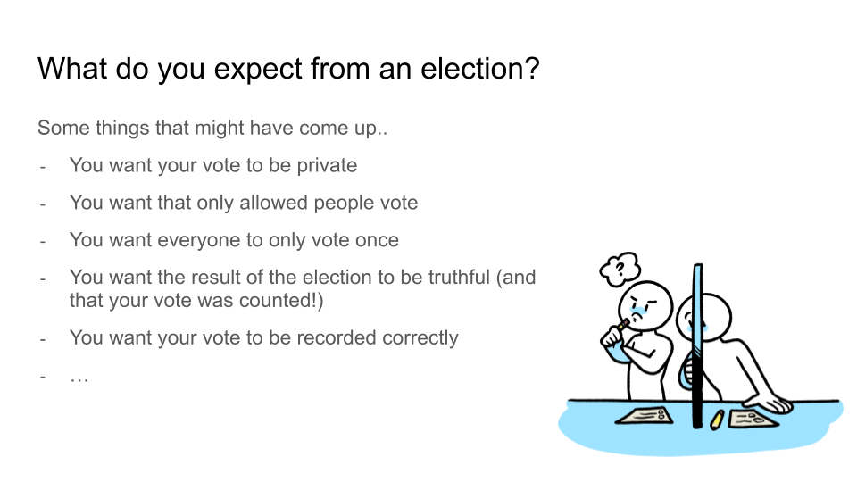

A motivating example that we use to engage with students is thinking about an election.

We ask the students whether they have ever voted for something, and to think about what *security* properties they expect from this process. Possible answers to this are made explicit on slide 4.

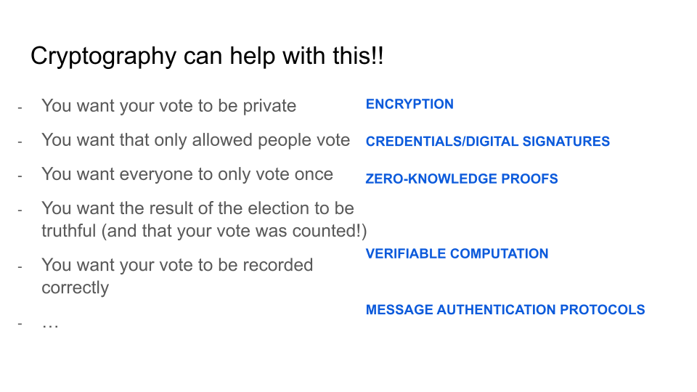

This is a technical slide, where we highlight what cryptographic tool (or primitive) can be used to achieve the properties identified earlier. In particular, *encryption* will help in keeping information private, *credential/digital signatures* will ensure only eligible people can vote, *zero-knowledge proofs* enable a user to prove that they have voted only once without revealing who they voted for, *verifiable computation* makes sure the final result is indeed the correct output. There is no need to go into details of each of the primitives, just naming them should expose the students to the breadth of the discipline and the variety of security properties it can provide.

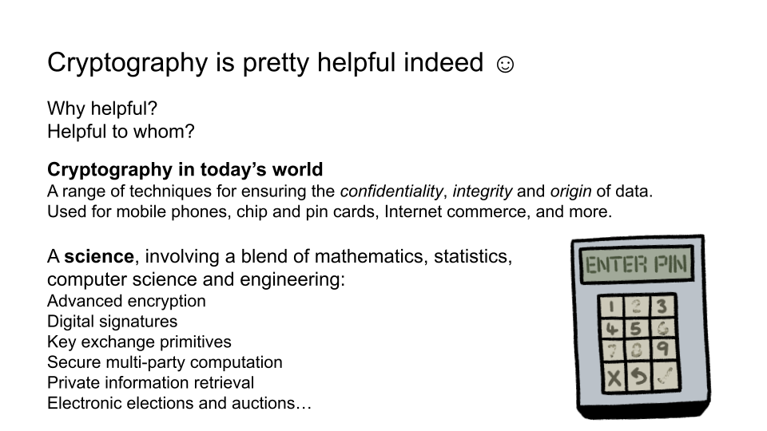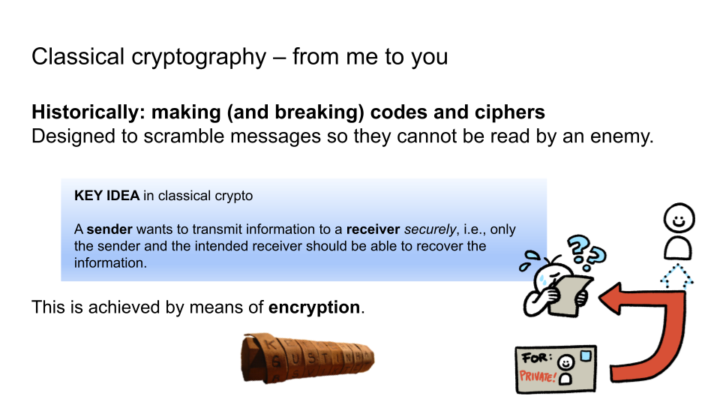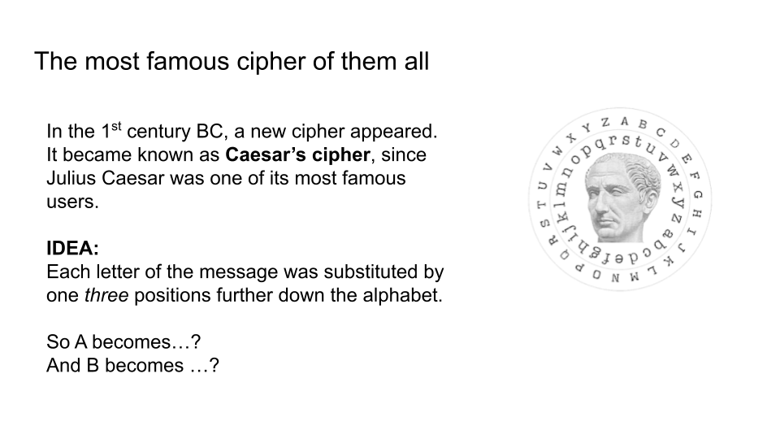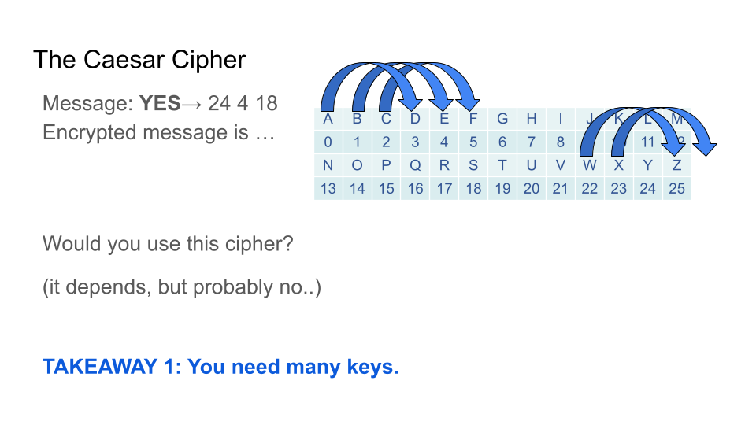

The above example should motivate why cryptography is useful, leading to a historical dive into the subject, which nowadays is no longer an art, but a full-on scientific discipline, blend of mathematics, computer science, engineering..

Cryptography’s history dates a long way back, and the students may be familiar with some examples of classical cryptography such as the Caesar cipher.

A brief description of it is provided, along with an explanation as to why this is not a very strong cipher, i.e., there are only 26 keys, so you can guess and soon you will find the right one. So takeaway message 1 is that you need many keys for security.

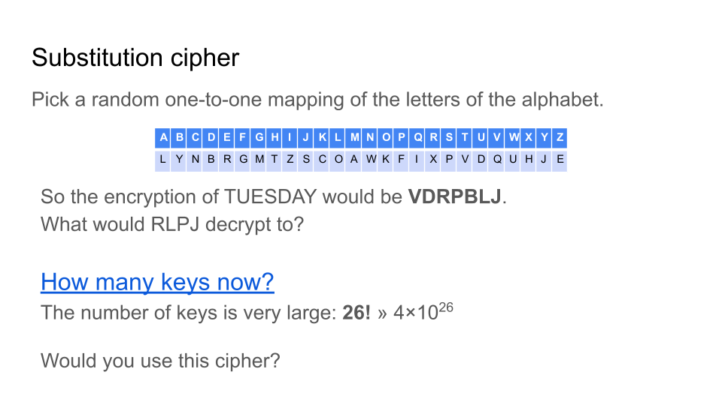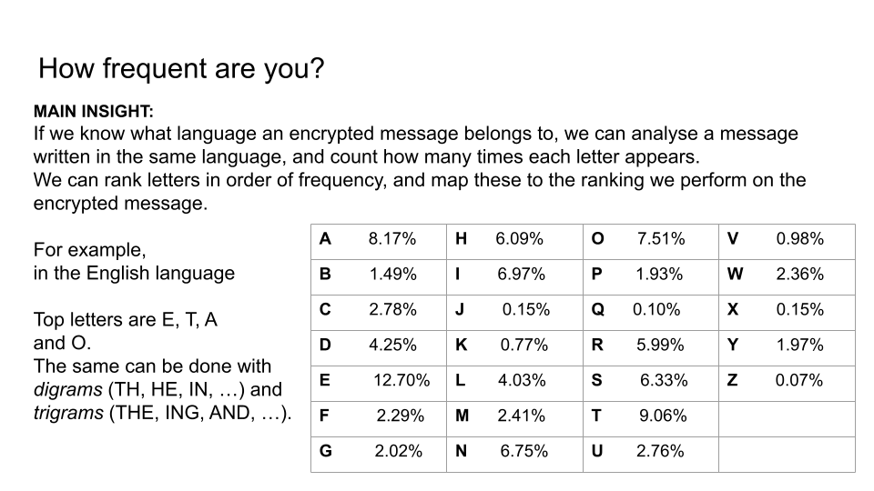

This leads to the study of another classical cipher, which overcomes the first issue. Indeed, the substitution cipher has now many keys, but still suffers from a limitation. The students are exposed to the concept of frequency analysis, and the fact that if you consistently map a letter to the same letter, the frequency pattern is maintained, leaking some information. So takeaway message 2 is that a lot of keys is not enough for security.

This eventually led to the shift towards polyalphabetic ciphers, where such pattern is meant to be broken.

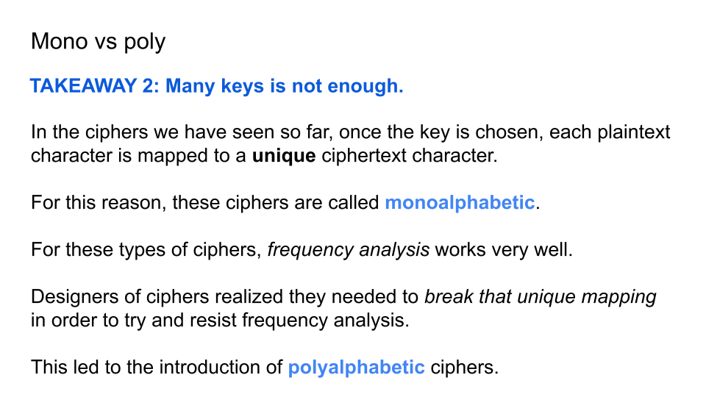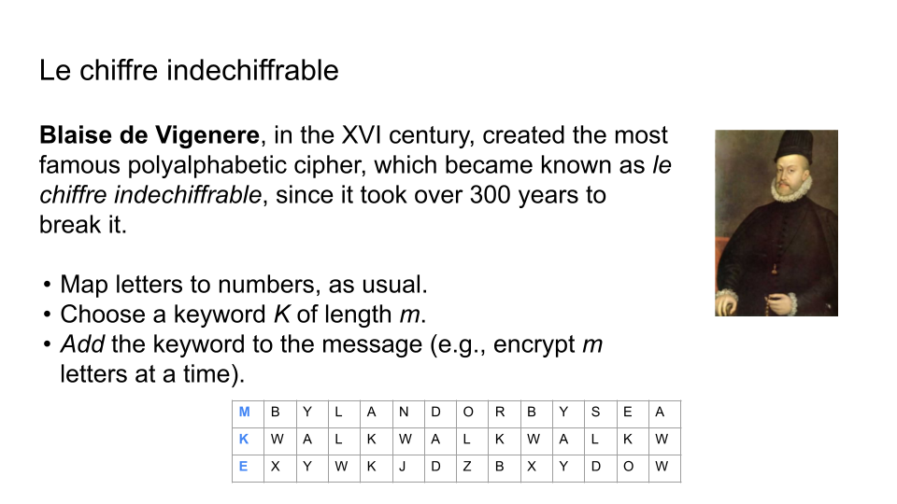We introduce another very famous cipher, the Vigenere cipher also known as the *unbreakable* cipher, which ironically was indeed broken – 300 years after it was proposed. This cipher attempted to break the pattern we earlier identified as a weakness, but unsuccessfully. The lesson learnt here is that believing a cipher is secure is not enough - we need some formal guarantee and a rigorous framework within which to reason about security properties.

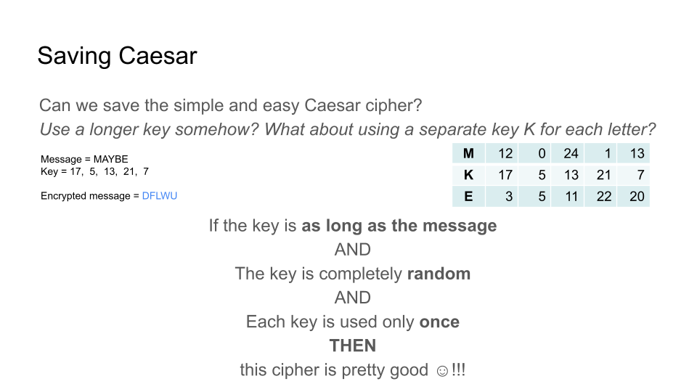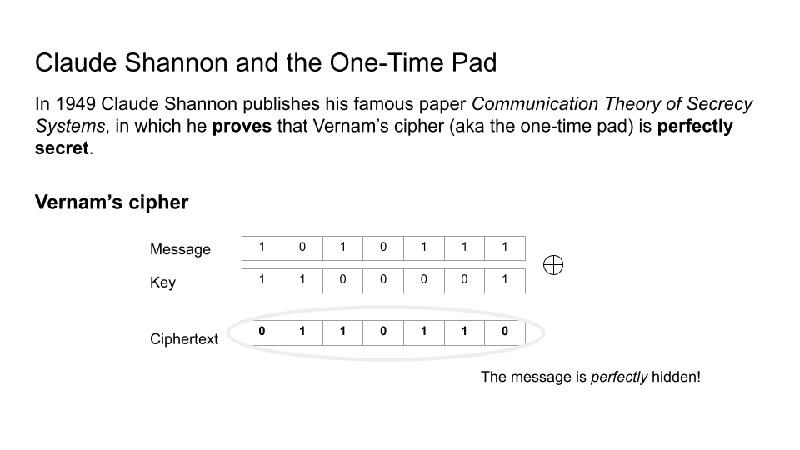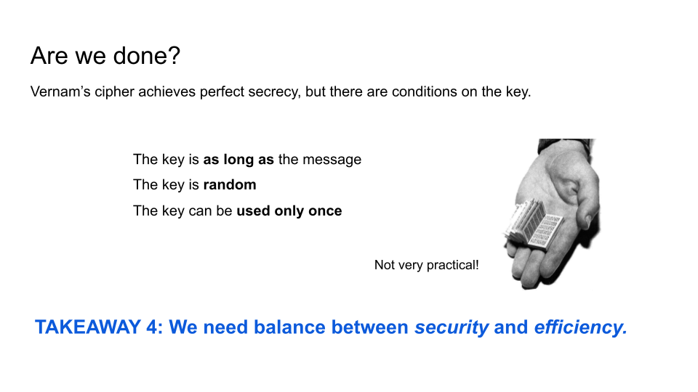

The quick historical voyage finally introduces one of the stepping stones in modern cryptography, which is the introduction of a formal definition of secrecy, allowing to formally prove a cipher is secret. This is (one of) the great contributions of Claude Shannon, in the field of Information Theory. Thanks to this, for the first time, a proof of security was provided for the One Time Pad (OTP), a perfectly secret cipher.

A description of OTP is given, along with the caveats for security, namely that perfect secrecy is achieved only under certain conditions, which severely impact its use in practice.

This leads to the motivation behind all modern cryptography, which is to find a balance between security and efficiency.

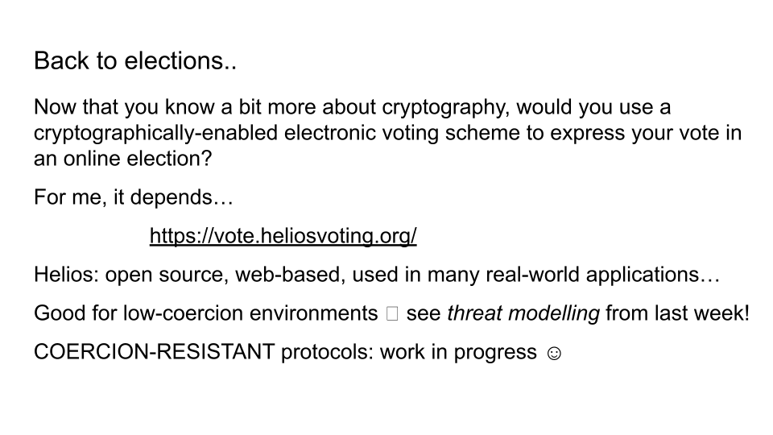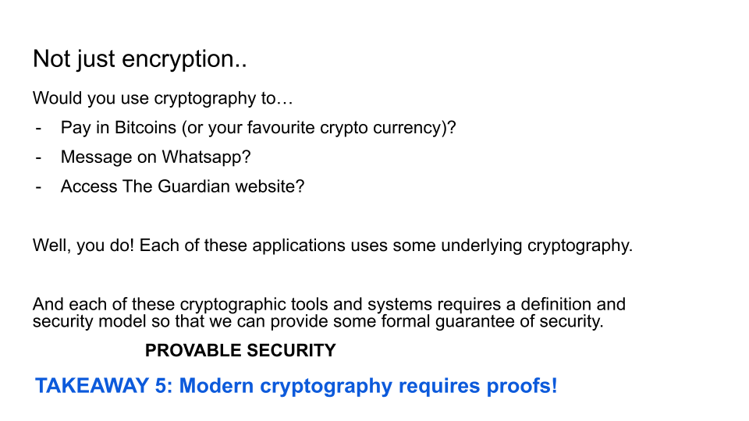

This theme is ever present in today’s cryptography, and the driving force behind much of its progress. The final slides of this lecture go back to the election examples, and challenge the student to think about whether cryptography is ready to achieve in practice what is needed.

And further examples are explored too - highlighting that, whether it is ready or not, we are already using it! And attacks and fixes to issues occur on a regular basis.

The hope is that this session inspires the students to think critically about what security they believe is needed in specific contexts, and question the guarantees that are promised.

Understanding the tool behind many of these applications is vital to understand what security can truly be provided.

## 

## Session 5: Complete Systems

### Tiger kidnappings

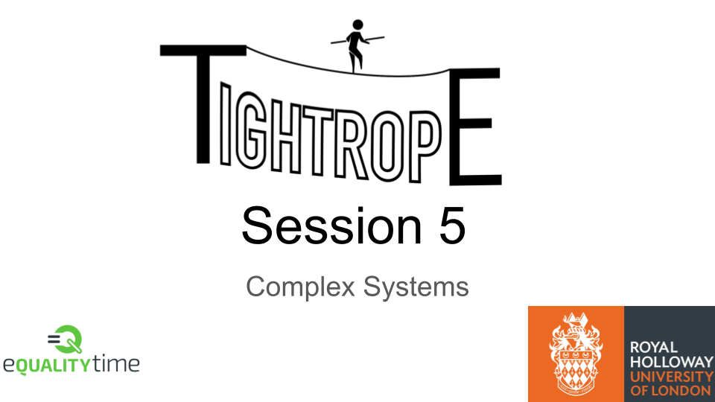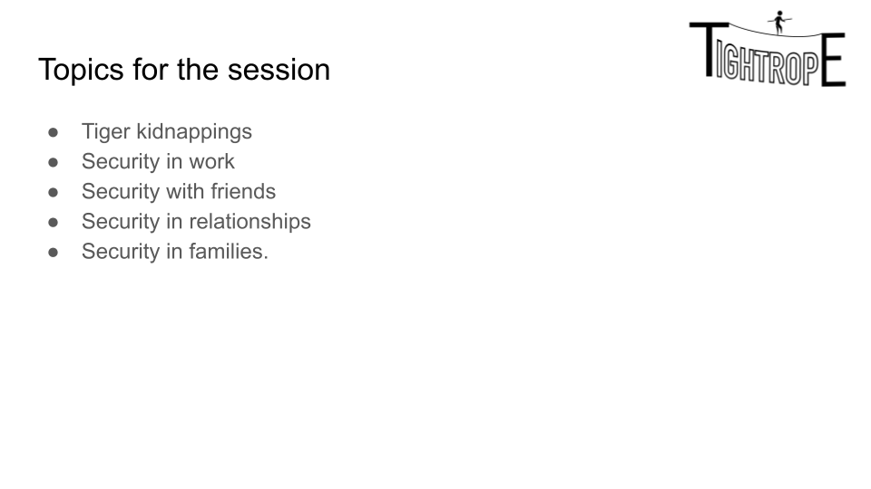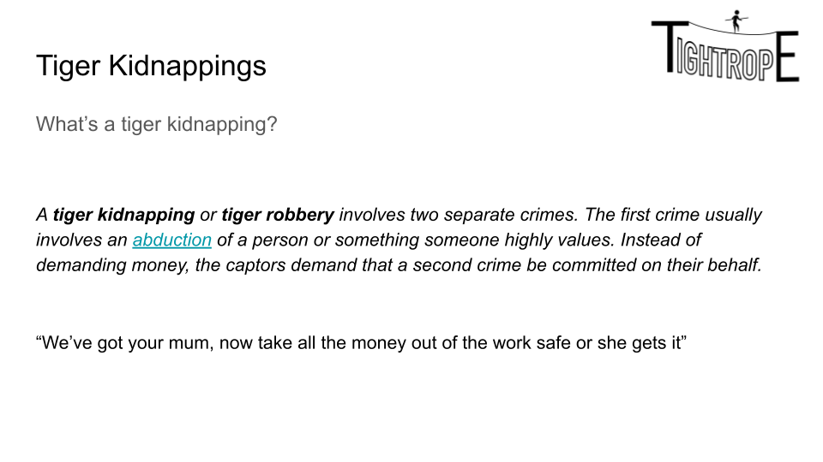

This is a simple introduction to Tiger Kidnappings. It’s worth reading <https://en.wikipedia.org/wiki/Securitas_depot_robbery> and <https://en.m.wikipedia.org/wiki/Northern_Bank_robbery> in advance. The key takeaways are:

* It’s almost impossible for a business to effectively defend against a Tiger kidnapping. Employees won’t take the risks (and we wouldn’t want them to)
* Thus the burden of the ‘security’ is on the police - can they regularly catch people *after* a Tiger Kidnapping so that it’s not as attractive an option.

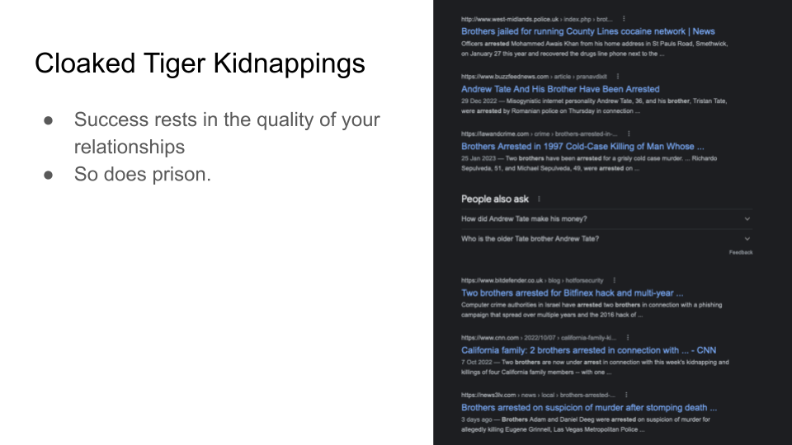

The image on the right is just a google should for ‘brothers’ and ‘prison’.

The point this slide makes (to foreground some things for later) is that some social situations can end up as effective tiger kidnapings. Examples include - feeling pressured to give an alibi for a family member, or being put in a situation of general harm. This is especially obvious from talking to prison inmates.

### Complex Systems

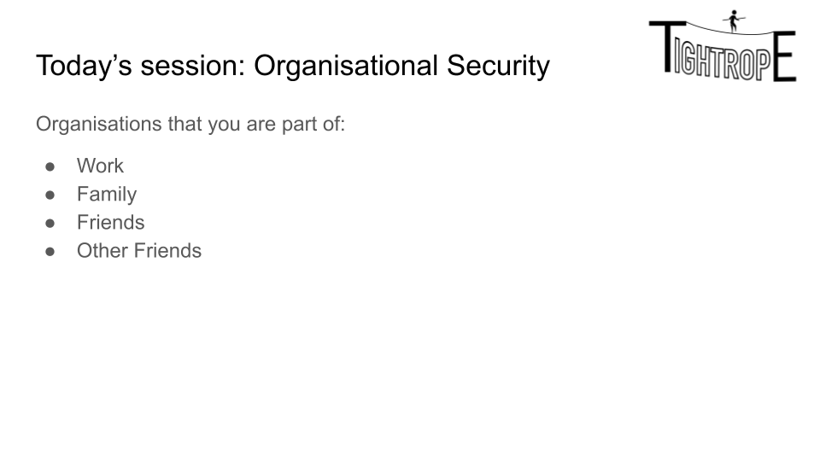

Ask the students which of the above are hardest to make secure. Normally we get a 50-50 split between Work and Family. Tell them that Work is easily and we’re going to work through the sets in order of how hard they are to make secure.

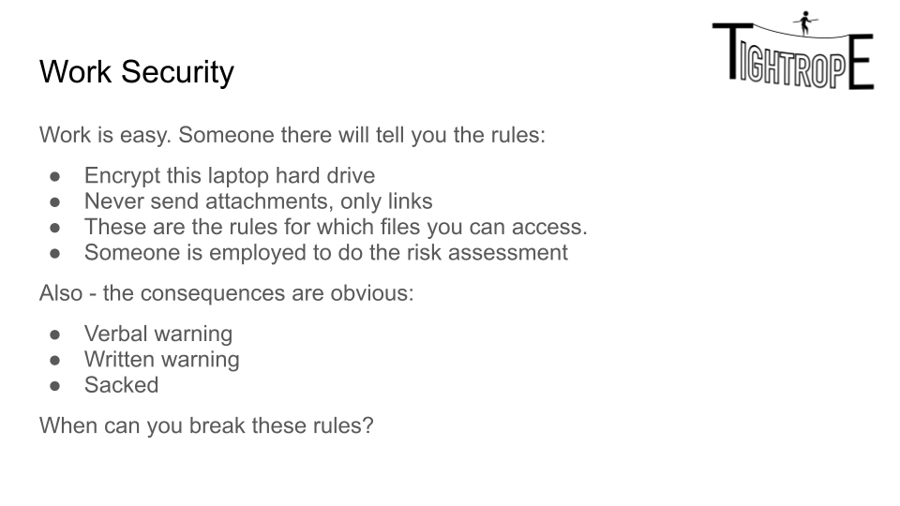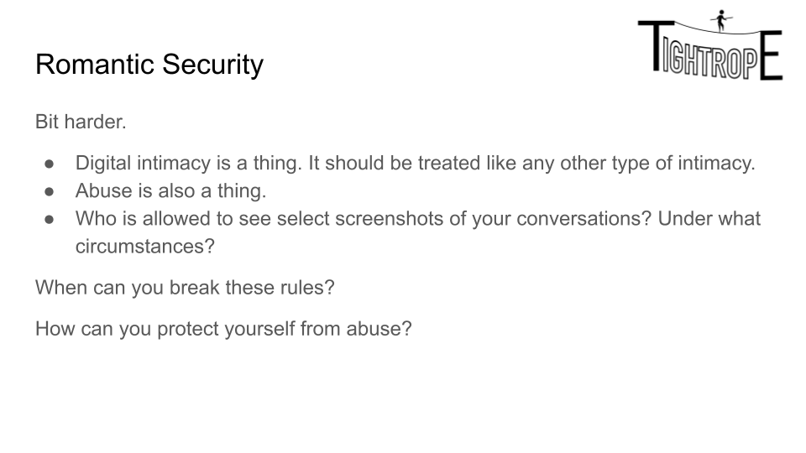

The work security slide is for general conversation. Some tact and age-appropriate conversation is needed for romance slide, but it’s an important one for the students - they should think hard about digital intimacy.

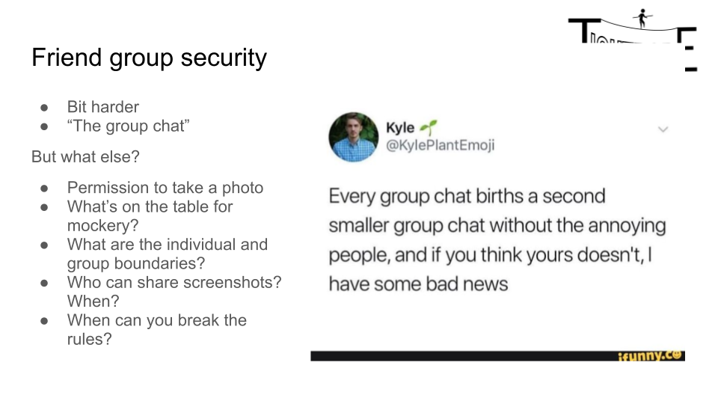

Have a general conversation about the rules and ask if they have talked about them, and if they think everybody understands the rules the same way.

Once they are comfortable with it, talk to them about the Warick Group Chat scandal (triggering for threats of sexual violence <https://www.bbc.co.uk/news/uk-48366835>).

If you have time, broaden the conversation out to ‘group chat of the people trying to make a change with you’ and ask how it’s different.

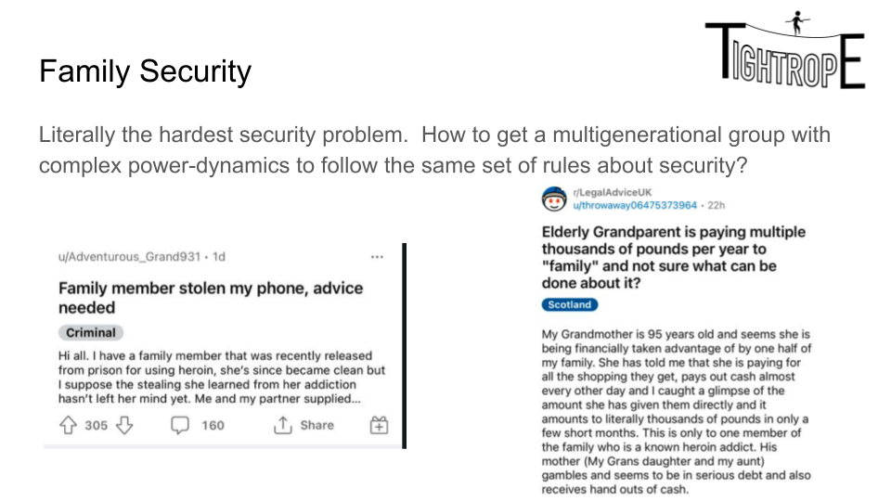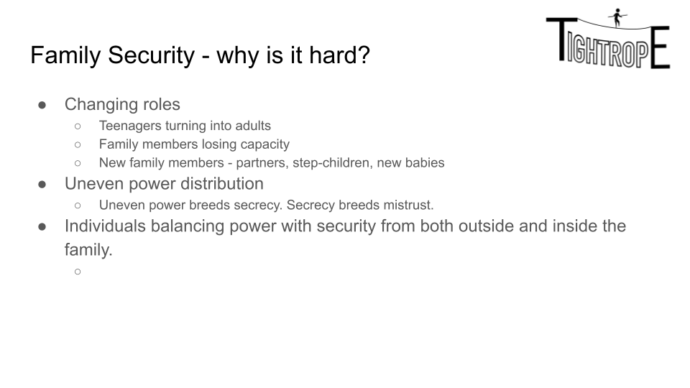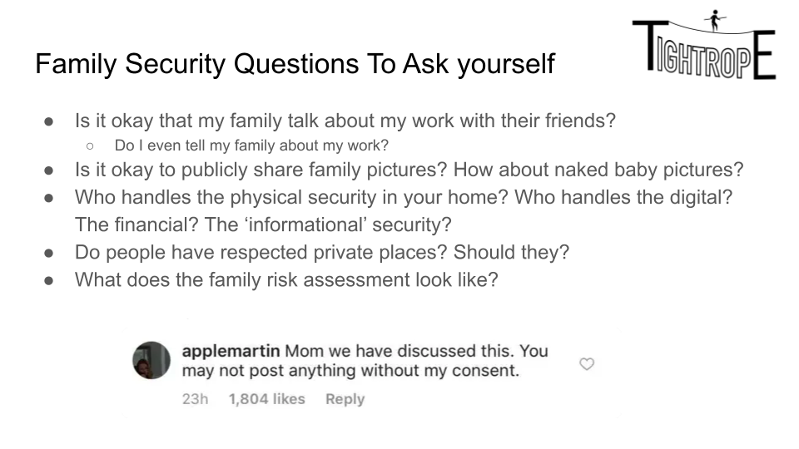

Lead a gentle conversation about risk in family situations and how it’s managed. The ‘applemartin’ screenshot is Gwyneth Paltrow’s daughter commenting on a photo her mum put up.

## Session 6: Scams and Magic

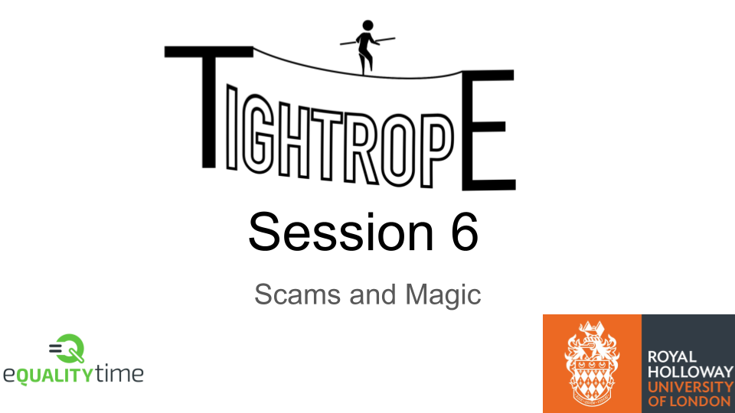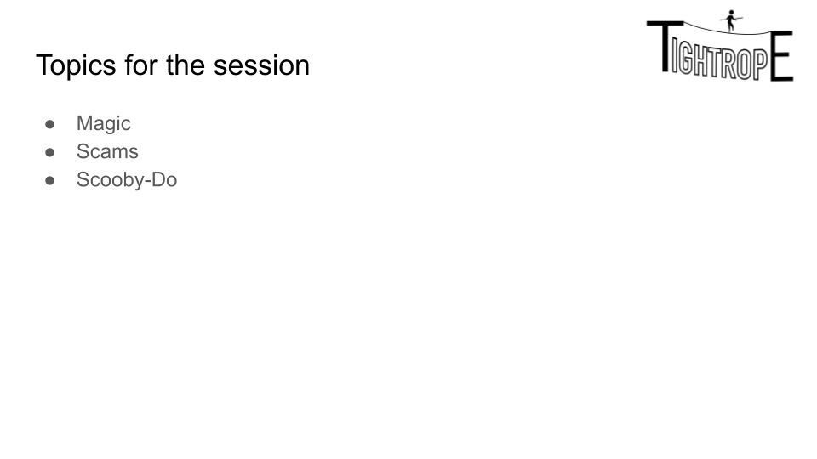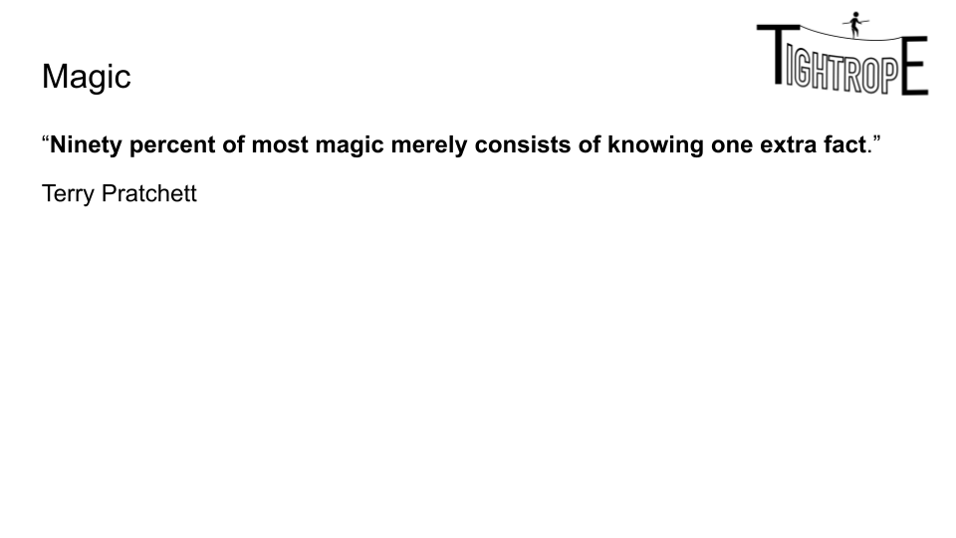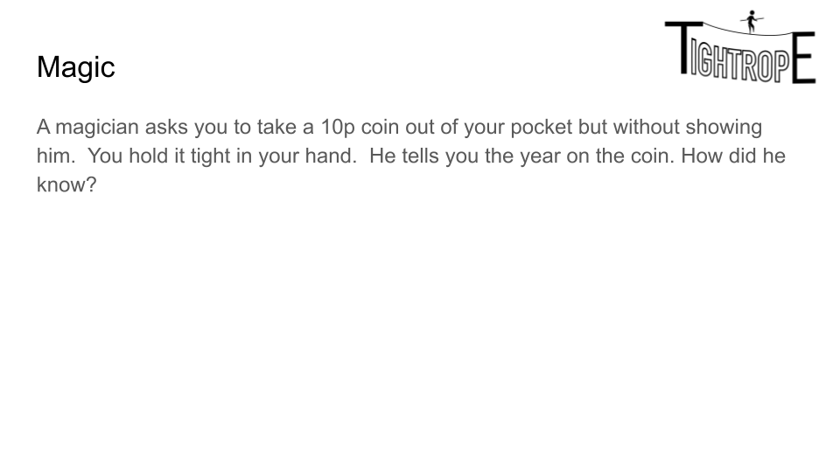

The UK changed to a smaller 10p in 1992, so the vast majority of 10p coins in circulation have this year on them. That’s the one additional fact mentioned before (This is a Derren Brown trick, but let the student’s know he doesn’t use it any more because it’s getting increasingly unreliable)

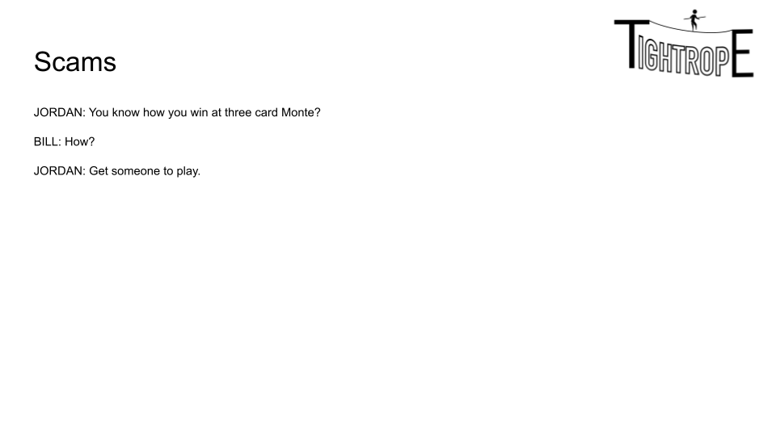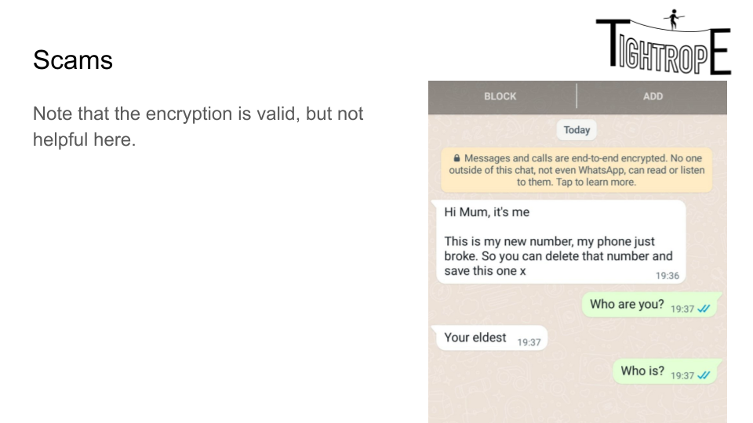

Ask the students if their parents would fall for this, and what would happen. Then tactfully broaden it out to grandparents.

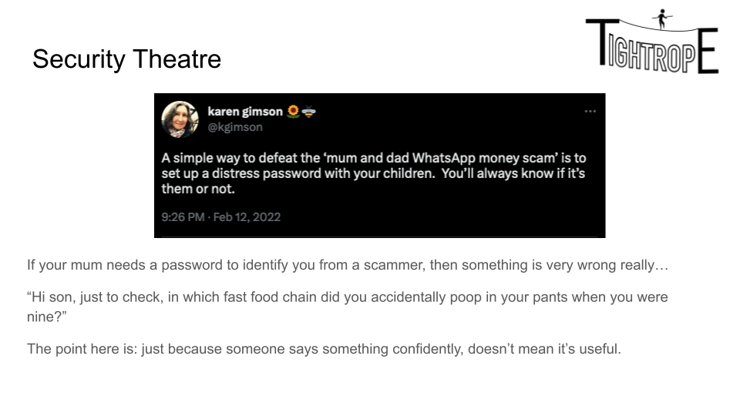

This is a great time to introduce the concept of ‘security theatre’ (there is a not particularly good wikipedia article here: <https://en.wikipedia.org/wiki/Security_theater>).

‘Security Theatre’ are practices that don’t help with security (a good example is when a website has particularly strange password rules) but looks like it does to reassure people.

### Advance Fee Fraud

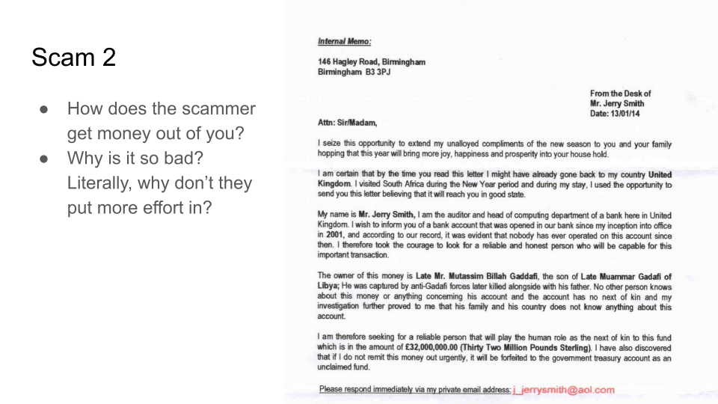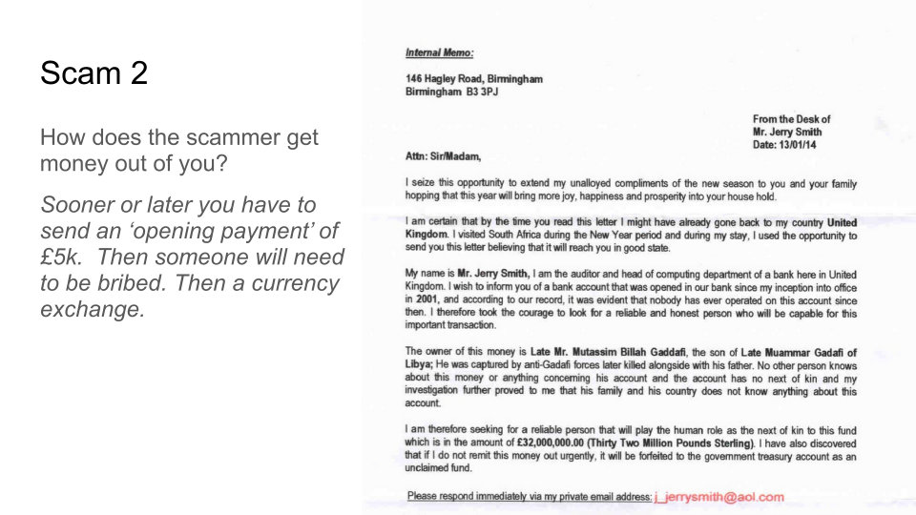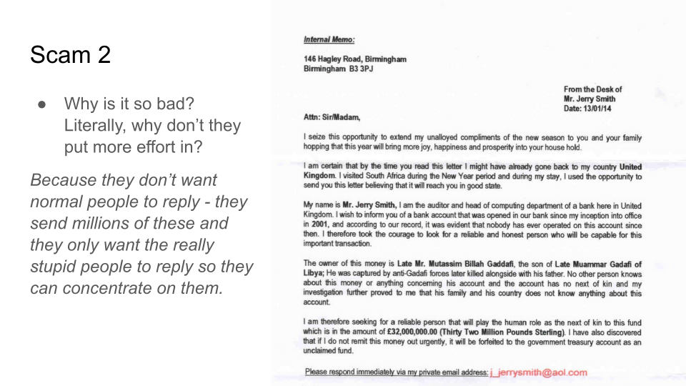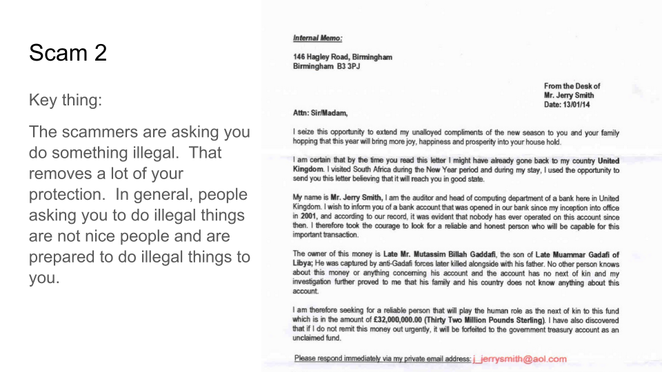

An overview of advance-fee fraud. Worth reading <https://en.wikipedia.org/wiki/Advance-fee_scam> first and definitely <https://gizmodo.com/why-nigerian-scammers-say-theyre-from-nigeria-5919818>

If you want to find out more you can also look at <https://en.wikipedia.org/wiki/419eater.com>, which is a strange community all of its own.

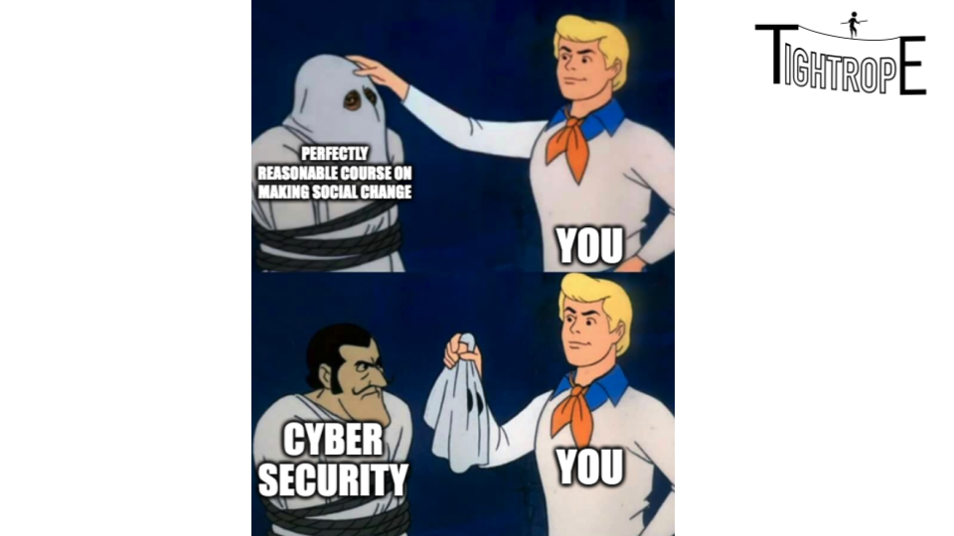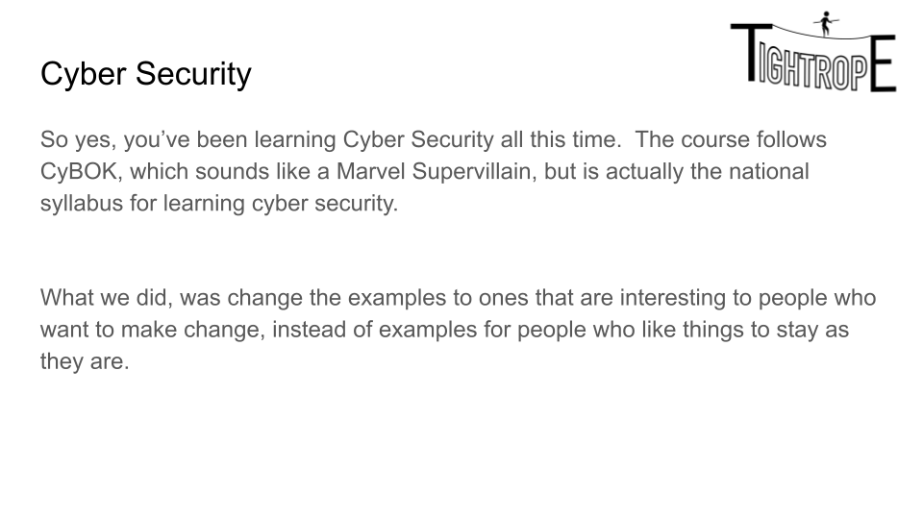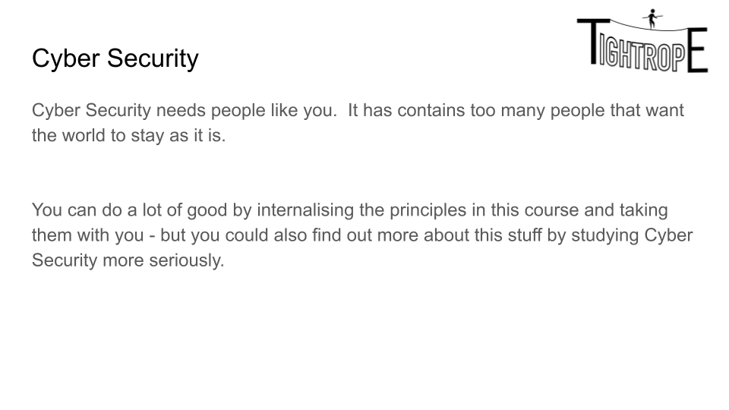

1. Or indeed “advocate in favour of animal testing” - we are deliberately neutral on what students want to achieve as long as they are safe doing it. The set change cards discussed below contain a lot of pairs of cards that are direct opposites.
2. Ironically the workspace is inherently very easy to secure - there are clear sets of rules, clear hierarchies, established consequences, security breaches and lots of laws.
3. United Nations' Sustainable Development Goals:<https://www.un.org/sustainabledevelopment/sustainable-development-goals/>
4. Or indeed “advocate in favour of animal testing” - we are deliberately neutral on what students want to achieve as long as they are safe doing it. The set change cards discussed below contain a lot of pairs of cards that are direct opposites.
5. It’s important to me. I’m just aware that there are other viewpoints.
6. Obviously, it’s also not that big of a problem if it was common. Some things are never going to be big problems.
7. It was me, It was also probably for the best.
8. I have done this to get the names of my neighbours’ correct when I moved into a new area. I got the impression that nobody had ever asked before.
9. It is surprising but outwardly cynical and jaded teenagers often can’t actually think of a single specific thing that might go wrong.
10. Particularly when we’ve already established that they are probably worrying about the wrong thing.